*Florida International University*

*Knight Foundation School of Computing and Information Sciences*

Software Engineering Focus

Final Deliverable

Project Title: Library Website

**Team Members:**

1. Andrew Mead
2. Douglas Pittman
3. Josejavier Navarro
4. Joshua Jaime
5. Stephanie Gremillion

**Product Owner**: Stephanie Gremillion

**Scrum Master**: Andrew Mead

**Instructor**: Masoud Sadjadi

The MIT License (MIT)

Copyright (c) *2016 Florida International University*

Permission is hereby granted, free of charge, to any person obtaining a copy of this software and associated documentation files (the "Software"), to deal in the Software without restriction, including without limitation the rights to use, copy, modify, merge, publish, distribute, sublicense, and/or sell copies of the Software, and to permit persons to whom the Software is furnished to do so, subject to the following conditions:

The above copyright notice and this permission notice shall be included in all copies or substantial portions of the Software.

THE SOFTWARE IS PROVIDED "AS IS", WITHOUT WARRANTY OF ANY KIND, EXPRESS OR IMPLIED, INCLUDING BUT NOT LIMITED TO THE WARRANTIES OF MERCHANTABILITY, FITNESS FOR A PARTICULAR PURPOSE AND NONINFRINGEMENT. IN NO EVENT SHALL THE AUTHORS OR COPYRIGHT HOLDERS BE LIABLE FOR ANY CLAIM, DAMAGES OR OTHER LIABILITY, WHETHER IN AN ACTION OF CONTRACT, TORT OR OTHERWISE, ARISING FROM, OUT OF OR IN CONNECTION WITH THE SOFTWARE OR THE USE OR OTHER DEALINGS IN THE SOFTWARE.

***Abstract***

*This document presents the information necessary to gain a good understanding of the Library Website. The website was built using the Scrum framework for project management, and each contributor played at least one critical role on the Scrum team: Product Owner, Scrum Master, or Developer. The website was built using the Python-based web framework Django and includes HTML, CSS, and JavaScript. It has a PostgreSQL database and was deployed using the Heroku cloud platform as a service. This report documents the Library Website as a product and outlines the Scrum process of the development team.*

**Table of Contents**

**Introduction**  5

Current System 5

Purpose of New System 5

**User Stories** 6

Implemented User Stories 6

Pending User Stories 8

**Project Plan** 9

Hardware and Software Resources 9

*Sprints Plan 10*

*Sprint 110*

*Sprint 2 11*

*Sprint 3 13*

*Sprint 4 15*

**system Design** 16

Architectural Patterns 17

System and Subsystem Decomposition 18

Deployment Diagram 19

Design Patterns 20

**System Validation** 21

**Glossary** 26

**Appendix** 28

Appendix A - UML Diagrams 28

*Static UML Diagrams* 29

*Dynamic UML Diagrams* 30

Appendix B - User Interface Design 31

Appendix C - Sprint Review Reports 32

Appendix D - User Manuals, Installation/Maintenance Document, Shortcomings/Wishlist Document and other documents 37

**References** 70

# Introduction

## Current System

The current system is the library website in which the team created throughout the duration of the four sprints in the semester. Library websites are not new as they have been around for a while as the team acknowledges that there are more sophisticated library websites compared to our product. Publicly owned library websites have a user enter their library card to validate that they do have a library card for the website that they are currently on. This process is not only limited to website as have been apps created in order to allow users to read books on tablets or smart phones, one example is Libby which has the user select their library and enter their library card number in order to borrow books, audiobooks, and comic books to read digitally.

## Purpose of New System

The purpose behind the system was to expand upon Mozilla’s Django tutorial which was a barebones library website. We added features that are the norm in library websites such as a search bar or reserving a book. In short, we used library websites as our basis and then put our own creative spin on it in order to make it stand out while in the process of exposing ourselves into the web development field.

# User Stories

The following section provides the detailed user stories that were implemented in this iteration of the Library Website project. These user stories served as the basis for the implementation of the project’s features. This section also shows the user stories that are to be considered for future development.

## Implemented User Stories

* **User Story (1):** As a library member, I want to visit a simple website for my library so that I can find basic information about my library without having to visit in person.
* **User Story (2):** As a library member, I want to see books including author, genre, language, and copies available on my library’s website so that I can plan my next book.
* **User Story (3):** As a library member, I want to see up-to-date information managed by library staff on my library’s website so that I can be sure the book I want is available.
* **User Story (4):** As a library member, I want my library’s website to have a simple home page with sidebar navigation so that I can easily find what I’m looking for.
* **User Story (5):** As a library member, I want my library’s website to have detailed pages for books and authors so that I can see more information when I want to.
* **User Story (7):** As a library member, I want to be able to log into my library’s website so that what I see matches what I can do based on whether I am an employee or not.
* **User Story (8):** As a library member, I want librarians to renew books and create, update, and delete books without using the admin site of my library’s website so that the information I need can be securely updated.
* **User Story (9):** As a library member, I want my library website to work even as changes are made to it so that there is not interruption for me as the end user.
* **User Story (10):** As a library member, I want my library’s website deployed on a public server so that I can visit it whenever I want.
* **User Story (11):** As a library member, I want my library’s website to have good security so that my information is secure from the outside world.
* **User Story (31):** Adding a search bar to the website
* **User Story (32):** Adding a user account home page after login - When user logs in, they should be greeted by their account home page. This page will show the books they’ve borrowed (and other related features to be added).
* **User Story (34):** Update author detail page with biography and image – The author detail pages should have a short biography about the author. The page should also have an image of the author.
* **User Story (36):** Update website to be more attractive (color, font, stylization, etc.) – The website should be designed to be more attractive to the user. Spacing, indentation, dividers, colors, fonts, etc. should all be considered.
* **User Story (38):** Allow users to leave reviews on books – Users should have the ability to leave reviews on books.
* **User Story (39):** Add book of the day and collections of books by genre on homepage – The homepage should display a preview of books in the catalog. There should be a “book of the day” that changes to a random book in the catalog.
* **User Story (40):** Add a book recommendations to book detail page (recommending same author/genre) – Book detail pages should recommend to users similar books based on author and genre.
* **User Story (41):** Add interface for new users to create their own accounts (asking for personal information) – New library users should be able to create a new account. The account will ask for things such as name and e-mail.
* **User Story (42):** Disable new users from borrowing books until their new accounts have been verified – When users create new accounts, they should not be able to borrow books until their accounts have been verified by a staff member account.
* **User Story (43):** Users can reserve and borrow books from the library – The books detail page should have the option for a user to reserve or borrow a book from that library. The return date should be an automatic (X weeks) from the day they borrow.
* **User Story (47):** Allow user to view genres
* **User Story (48):** Allow user to view languages
* **User Story (49):** Add a contact system for librarians and users – The users should have a place they can submit questions or concerns to the librarians. Additionally, the librarians should have a way to see all of the submissions and respond.
* **User Story (50):** Navigation bar at top of page
* **User Story (51):** Search bar additionally accepts author and keyword input – Users should be able to enter an author name or keyword (from book description, language, or genre) into the search bar. Books or authors matching the keywords should be displayed on the results page.
* **User Story (52):** Add images to author and book detail pages – Author and book images should be added to the details page
* **User Story (54):** Create an event calendar – The staff need a way to show users special events being held by the library. There should be a calendar with the marked days of events and a list of events on an “Events” page.
* **User Story (58):** The website should have a contact page- The contact page should show the information for the staff (names, e-mail) and the library (address, hours, etc.).
* **User Story (59):** Website needs to be tested for accessibility

## Pending User Stories

* **User Story (37):** Allow users to save and remove books from a personal reading list – Users should be able to view, add, and remove books from their own personal reading list.
* **User Story (44):** Enable librarian to disable user account borrow feature – Librarians should have the ability to disable the borrowing capabilities of users.
* **User Story (45):** Books should have different format options
* **User Story (46):** Library should have a kids’ section – There should be a page for a kids’ section of books. This should list all of the books that are tagged for kids. Additionally, books should have a variable that signifies whether or not it is appropriate for kids.
* **User Story (53):** Replace pagination with “load more” button – When viewing a list, users should be able to press a “load more” button at the bottom of the list. This way, they can scroll back up to find a book they’ve already seen.
* **User Story (60):** CSS needs to have tailored option for smaller screens – Websites show up differently on smaller screens (phones, tablets, etc.) and need to have their CSS styles verified for compatibility. Some CSS rules might need to be put in place to make sure the website works properly.
* **User Story (61):** Website CSS needs a central theme – Instead of developing each page individually, there should be a central “theme.” Because we use Tailwind CSS, we have the ability to make themes that have a general set of design rules for a website and its elements.

# Project Plan

This section describes the planning that went into the realization of this project. This project incorporated the agile development techniques and as such required the sprints to be planned. These sprint plannings are detailed in this section. This section also describes the components, both software and hardware, chosen for this project.

## Hardware and Software Resources

The following is a list of all hardware and software resources that were used in this project:

* Python
  + Django framework
  + Python’s package manager “Pip”
* Jira
* Heroku
  + Heroku Command Line Interface (CLI)
* GitHub
* Discord
* Microsoft Word Online

## 

## 

## Sprints Plan

### Sprint 1

Date: 10/10/22

Start time: 7PM

End time: 7:30PM

After discussion, the velocity of the team was estimated to be 30 points.

The product owner chose the following user stories to be done during the next sprint. They are ordered based on their priority.

* User Story (1) As a library member, I want to visit a simple website for my library so that I can find basic information about my library without having to visit in person.
* User Story (2) As a library member, I want to see books including author, genre, language and copies available on my library’s website so that I can plan my next book.
* User Story (3) As a library member, I want to see up-to-date information managed by library staff on my library’s website so that I can be sure the book I want is available.

The team members indicated their willingness to work on the following user stories.

* Joshua Jaime
* User Story (1) As a library member, I want to visit a simple website for my library

so that I can find basic information about my library without having to visit in

person.

* Douglas Pittman
* User Story (2) As a library member, I want to see books including author, genre,

language and copies available on my library’s website so that I can plan my next

book.

* Josejavier Navarro
* User Story (3) As a library member, I want to see up-to-date information

managed by library staff on my library’s website so that I can be sure the book I

want is available.

### Sprint 2

Date: 10/24/22

Start time: 8:00PM

End time: 8:45PM

After discussion, the velocity of the team was estimated to be 50 points.

The product owner chose the following user stories to be done during the next sprint. They are ordered based on their priority.

* User Story (7): As a library member, I want to be able to log into my library’s website so that what I see matches what I can do based on whether I am an employee or not.
* User Story (9): As a library member, I want to the website to have a feature where the librarians can add books and authors by filling out fields such as the name or the author of the name of the book.
* User Story (10): As a library member, I want to ensure that the site loads and that everything is functional.
* User Story (11): Deploying Django to production
* User Story (12): As a library member, I want my library’s website to have good security so that my information is secure from the outside world.
* User Story (13) : As a library member, I want the website to have a search bar where it can allow the user to either search for the name of a book or for an author.
* User Story (14): As a library member, I’d like to have access to additional information on the author so that I can find other works by the author if I like the initial book that I check out.
* User Story (16): Adding a user account home page after login
* User Story (21): Add interface for new users to create their own accounts (asking for personal information)
* User Story (22): Disable new users from borrowing books until their new accounts have been verified (add this feature to staff accounts)

The team members indicated their willingness to work on the following user stories.

* Gremillion, Stephanie
* User Story (11): Deploying Django to production
* User Story (16): Adding a user account home page after login
* Jaime, Joshua
* (User Story 21) Add interface for new users to create their own accounts (asking for personal information)
* (User Story 22) Disable new users from borrowing books until their new accounts have been verified (add this feature to staff accounts)
* Mead, Andrew
* User Story (7): As a library member, I want to be able to log into my library’s website so that what I see matches what I can do based on whether I am an employee or not.
* User Story (12): As a library member, I want my library’s website to have good security so that my information is secure from the outside world.
* Navarro, Josejavier
* User Story (9): As a library member, I want to the website to have a feature where the librarians can add books and authors by filling out fields such as the name or the author of the name of the book.
* User Story (13) : As a library member, I want the website to have a search bar where it can allow the user to either search for the name of a book or for an author.
* Pittman, Douglas
* User Story (10): As a library member, I want to ensure that the site loads and that everything is functional.
* User Story (14): As a library member, I’d like to have access to additional information on the author so that I can find other works by the author if I like the initial book that I check out.

### Sprint 3

Date: 11/7/22

Start time: 8:00PM

End time: 8:30PM

After discussion, the velocity of the team was estimated to be 59 points.

The product owner chose the following user stories to be done during the next sprint.

They are ordered based on their priority:

1. User Story (8 points): Search bar additionally accepts author and keyword inputs
2. User Story (8 points): Enable librarian to disable user account borrow feature
3. User Story (8 points): Add images to author and book detail pages
4. User Story (8 points): Allow users to leave reviews on books
5. User Story (8 points): Disable new users from borrowing books until their new accounts have been verified
6. User Story (5 points): Add book of the day/collections of books by genre on homepage
7. User Story (5 points): Add a book recommendations to book detail page
8. User Story (3 points): Navigation bar at top of page
9. User Story (3 points): Allow user to view genres
10. User Story (3 points): Allow user to view languages

The team members indicated their willingness to work on the following user stories.

* Gremillion, Stephanie
  1. User Story (8 points): Add images to author and book detail pages
  2. User Story (3 points): Navigation bar at top of page
* Jaime, Joshua
  1. User Story (8 points): Disable new users from borrowing books until their new accounts have been verified
* Mead, Andrew
  1. User Story (5 points): Add book of the day/collections and books by genre on homepage
  2. User Story (3 points): Allow user to view genres
  3. User Story (3 points): Allow user to view languages
* Navarro, Josejavier
  1. User Story (8 points): Have the search bar also accept keywords and author names
  2. User Story (8 points): Enable librarians to disable user account borrowing feature
* Pittman, Douglas
  1. User Story (5 points): Add book recommendations to the book detail page (recommending same author/genre)
  2. User Story (8 points): Allow users to leave reviews on books

### Sprint 4

Date: 11/21/22

Start time: 9:00PM

End time: 9:30PM

After discussion, the velocity of the team was estimated to be 71 points.

The product owner chose the following user stories to be done during the next sprint.

They are ordered based on their priority:

1. User Story (39): Add book of the day and collections of books by genre on homepage
2. User Story (38): Allow users to leave reviews on books
3. User Story (46): Library should have a kids section
4. User Story (58): The website should have a contact page
5. User Story (59): Website needs to be tested for accessibility
6. User Story (54): Create an event calendar
7. User Story (53): Replace pagination with "load more" button
8. User Story (49): Add a contact system for librarians and users
9. User Story (43): Users can reserve and borrow books from the library
10. User Story (45): Books should have different format options

The team members indicated their willingness to work on the following user stories.

* Gremillion, Stephanie
  1. User Story (59): Website needs to be tested for accessibility
  2. User Story (54): Create an event calendar
* Jaime, Joshua
  1. User Story (49): Add a contact system for librarians and users.
* Mead, Andrew
  1. User Story (39): Add book of the day and books by genre on homepage
  2. User Story (46): Library should have a kids section
  3. User Story (58): The website should have a contact page
* Navarro, Josejavier
  1. User Story (53): Replace pagination with “load more” button
  2. User Story (43): Users can reserve and borrow books from the library
* Pittman, Douglas
  1. User Story (38): Allow users to leave reviews on books
  2. User Story (45): Books should have different format options

# System Design

This section contains information on the design decisions that went into this project. The architecture patterns are outlined and explained. The entire system is shown in a package diagram and the subsystems are explained. Finally, the design patterns used in the project are discussed.

## Architectural Patterns

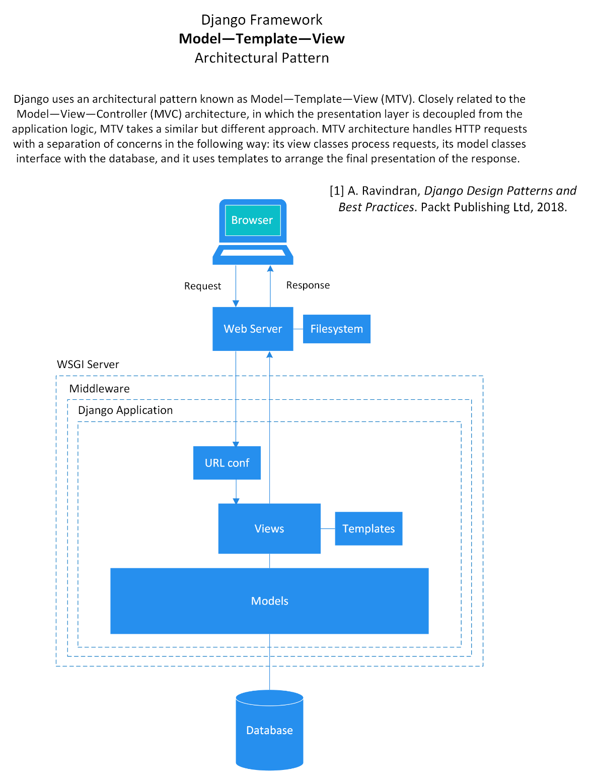

## System and Subsystem Decomposition

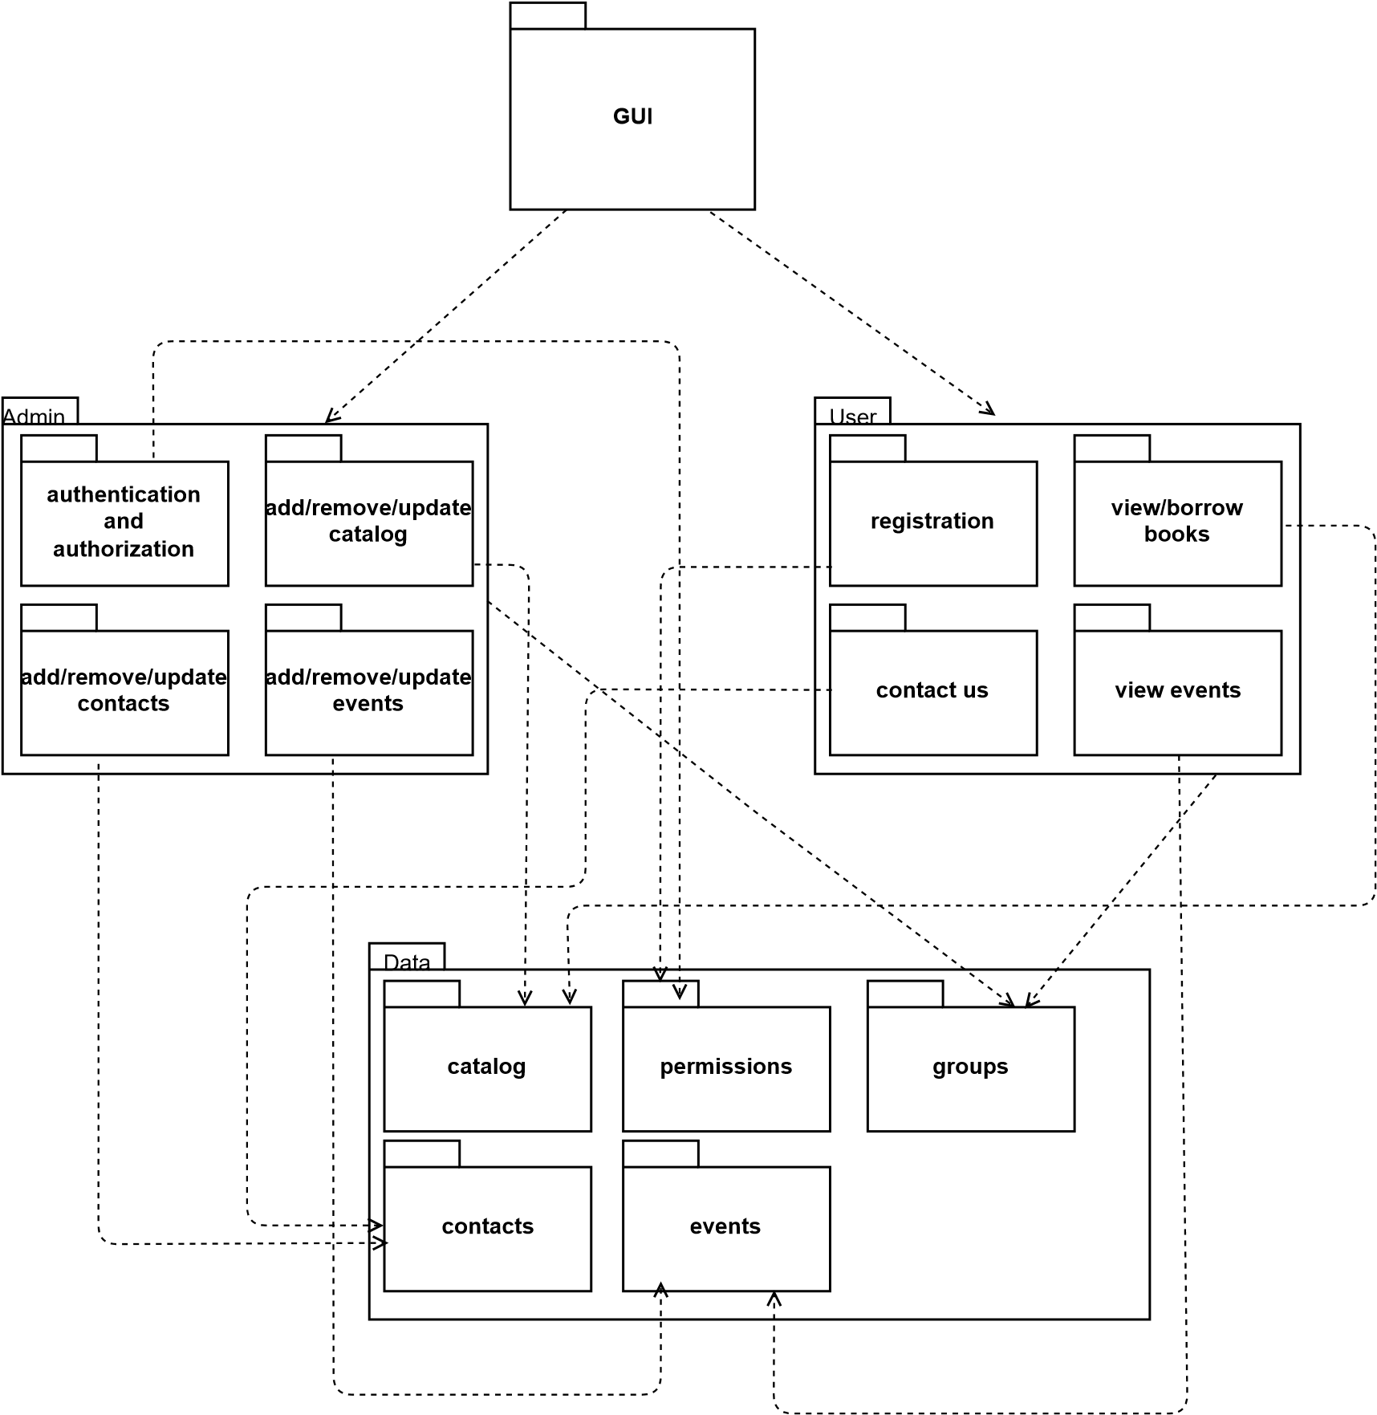

## Deployment Diagram

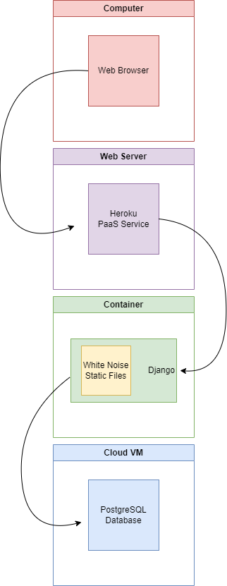

## Design Patterns

The Django framework, inspired by the software design classic *Design Patterns: Elements of Reusable Object-Oriented Software* by Erich Gamma, Richard Helm, Ralph Johnson, and John Vlisside, uses the

* Command Pattern through HttpRequest to encapsulate a request in an object,
* Observer Pattern through Signals to notify an object’s listeners when it changes state, and
* Template Method through Class-based view subclassing to override attributes and methods [1].

Inspired by Martin Fowler’s *Patterns of Enterprise Application Architecture,* the Django framework uses

* Active Record via Models to encapsulate database access and add domain logic to data,
* Class Table Inheritance through Models to map each entity in a hierarchy to a separate table,
* Identity Field through ID Field to save the database field in an object to maintain identity, and
* Template View via templates to render information into HTML by embedded markers in HTML [1].

# System Validation

The validation protocol covers the following qualifications:

1. Installation Qualification (IQ)

The purpose of IQ is to ensure that the website is properly installed in the right environment. The scope of IQ includes the following:

* Because the website is intended to be run via Heroku, we need to verify the qualifications of the cloud system.
  + Cloud servers, settings, characteristics
  + Cloud service provider contract
* Verifying the software environment settings match with environment requirements.
  + Package versions
  + Database versions
* Ensuring the website is properly installed.
* Migrating data from the database file to the cloud and local machine databases.

Results:

Tests have been done on Windows OS, macOS, and Ubuntu OS. Following the installation guide having already installed the requirements, pip was installed and a virtual environment was set up on a local machine.

Pip was used to install website requirements via the requirements.txt file. Each of the installed packages were checked for proper installation and correct versions. All versions of packages were correctly installed with the proper versions. PostgreSQL version 14 was properly installed and setup.

|  |  |
| --- | --- |
|  | Accepted |
| All requirements were correctly installed with the required version |  |
| The database software was properly installed with the required version |  |

A database on the local machine was created and the database file was imported. This populated the database with tables and information data. There were no fatal errors in populating the database on the local machine.

|  |  |
| --- | --- |
|  | Accepted |
| The database was properly populated from the given database file |  |
| There were no fatal errors populating the database |  |

The database information in the website’s settings.py file was updated with the new database credentials created on the local machine. The engine, host, and port were verified as being correct.

|  |  |
| --- | --- |
|  | Accepted |
| The information in settings.py is accurate |  |
| Changing the database information enables the database to run |  |

Once the website was verified to be working on the local machine, it was integrated with Heroku. Following the Heroku Deployment section of the installation guide, the files were added to a repository. The repository was pushed to Heroku to begin setup.

Using Git, the repository was pushed to Heroku. Then, using GitHub, the repository was connected to Heroku and then deployed manually followed by being set up for automatic deployment.

|  |  |
| --- | --- |
|  | Accepted |
| A git repository was successfully created |  |
| There were no errors pushing the git repository to Heroku |  |
| GitHub was integrated with Heroku |  |
| There were no errors with either manual or automatic deployment |  |
| Proper contracts for Heroku deployment were available |  |

1. Operations Qualification (OQ) and Performance Qualification (PQ)

The purpose of OQ is to ensure that every function of the website is working as expected. The scope of OQ includes the following:

* Functional requirements
  + Verifying the functions work
  + Website can be accessed as expected
* Non-functional requirements
  + Security
  + Administrative functions

The purpose of PQ is to ensure that the website works in the proper environment and with its target users.

Results:

Each of the operations of the website were tested for functionality.

The links of each page were tested for functionality and accuracy. Every link sent the user to the proper location. There were no errors in the links or menus.

|  |  |
| --- | --- |
|  | Accepted |
| Website pages display |  |
| Each link on each page sends the user to the correct location |  |

The website’s admin page was tested for functionality. Admin and staff user accounts can log in and change the appropriate information. Group functions work properly to give accounts the appropriate permissions. Users can be edited and changed, their information changed, their passwords reset, and their accounts deleted. Each category of the catalog can be fully edited, which reflects on the library website. Contacts can be viewed from the admin page. Events can be created, edited, and deleted.

|  |  |
| --- | --- |
|  | Accepted |
| The admin page can be accessed by proper accounts |  |
| Groups work properly to give accounts certain permissions |  |
| Users accounts can be added, edited, and deleted |  |
| The author category can be edited and reflects on the website |  |
| The book category can be edited and reflects on the website |  |
| The book instances category can be edited and reflects on the website |  |
| The comments category can be edited and reflects on the website |  |
| The genres category can be edited and reflects on the website |  |
| The languages category can be edited and reflects on the website |  |
| The library users category can give and remove permissions from user accounts |  |
| Contacts can be viewed and deleted |  |
| Events can be edited and reflects on the website |  |

The contact page was tested for functionality. The input fields accept input and give an error if the required fields are not used. The submit button works correctly

|  |  |
| --- | --- |
|  | Accepted |
| The contact page fields work and give the proper errors |  |
| The submit button works |  |

The login button was tested for functionality. It accepts username and password. Several accounts with various permissions were tested and work appropriately. The logout button functions to log the user out of the library website. Once logged in, the user has access to their user home page. The link and the page both function properly. If the user has staff status, they can view the page listing all of the borrowed books in the library. The link and the page both function properly.

|  |  |
| --- | --- |
|  | Accepted |
| Signing in requires a username and password and gives proper errors |  |
| Accounts with proper permissions can log in |  |
| Inactive accounts cannot log in |  |
| When password or username is incorrect, an error is given |  |
| The logout button functions for all account types |  |
| The user can see the account home link when logged in |  |
| The account home link functions |  |
| Once logged in, a staff account can see the link to view all borrow books |  |
| The link to view all borrowed books only works for staff accounts |  |

The sign-up button was tested for functionality. The sign-up form fields work properly and the required fields give error when not used properly. The password requirements function and give an error when incorrect properly. The sign-up button works once all of the fields are properly filled out. The sign in button at the bottom works properly and redirects the user to the sign in page.

|  |  |
| --- | --- |
|  | Accepted |
| The sign-up button redirects to the proper page |  |
| The input fields accept text input |  |
| The input fields give errors when used incorrectly |  |
| The password input field requirements give errors when used incorrectly |  |
| The form gives an error if not completely filled out |  |
| The sign-up button works and creates an account on completion |  |
| The sign in button redirects the user to the sign in page |  |

The search bar was tested for functionality. It successfully accepts input and compares the keywords input against the information in the library catalog. The search bar redirects to the proper search results page. It gives an error if no input was given.

|  |  |
| --- | --- |
|  | Accepted |
| The search bar accepts input |  |
| Correct results are returned from the input keywords |  |
| Errors are given if there is no input |  |

The dark mode button functions to turn the website into dark mode. The mode was tested on each page and element for functionality. There were no errors in functionality.

|  |  |
| --- | --- |
|  | Accepted |
| Dark mode works on all pages |  |

Comments on each book detail page function as expected. Logged in users can add, edit, and delete their own comments. Non-logged-in users can add comments but cannot edit or delete them, as expected.

|  |  |
| --- | --- |
|  | Accepted |
| Users with accounts can add comments |  |
| Users with accounts can edit or delete their own comments |  |
| Users without accounts can only add comments |  |

Similar books feature works on each book detail page. The section accurate suggests books similar to the book on that page by giving books by similar author or genre.

|  |  |
| --- | --- |
|  | Accepted |
| Similar books section shows books |  |
| Similar books are either same author or same genre |  |

# 

# 

# 

# Glossary

**active (user account)** – Refers to the status of a user account. An account that has been designated as “active” can be logged into and used by the user. Any account that is not designated as “active” will not be able to log in to the website and use account features.

**admin page** – The section of the library website used for administration and staff. The website can be viewed by going to [librarywebsite].com/admin and logging in with an administrative or staff account. The admin page gives access to changing all of the information on the library website, including the catalog and user accounts.

**administrative** – Refers to high level users or staff responsible for maintaining the website.

**book instance** – Refers to the individual copies of a book in the library. Each book instance has a unique identification number for differentiation. Also see **copy**.

**catalog** – The collection of books in the library. In reference to the library website, refers to the collection of books that are registered on the website.

**command prompt** – the program in which you can input text to interact with programs on a computer. Also known as cmd, cmd.exe, command line interface, and terminal.

**contacts** – The correspondence received from the Contact Us page on the website. Includes the sender’s information such as first name, last name, e-mail, and message.

**copy** - Refers to the individual copies of a book in the library. Each copy has a unique identification number for differentiation. Also see **book instance**.

**database, db.sql** – the collection of tables holding the information for the content of the library.

**detail page / view** – A page that has detailed information. A book detail page has all of the details of that specific book, including title, author, summary, etc. An author detail page has all of the details of that specific author, including name, significant dates, biography, etc.

**events** – Refers to the events being hosted by the library that are displayed on the Calendar.

**git** – a tool used for managing source code. Git is run directly on your computer.  
  
**GitHub** – similar to git, a tool used for managing source code. GitHub is mainly run from the GitHub website.

**gitignore** – the file in a repository that tells git which files to ignore when pushing to a repository (ex: ignoring your virtual environment directory)

**groups** – Refers to the collection of permissions given to user accounts. Account permissions can be arranged into groups, making it easier to keep track of which accounts have which permissions. Also see **permissions**.

**Heroku** – a could application platform that allows clients to build, run, and operate applications in the cloud or without hardware of their own.

**Heroku CLI** – the program installed on your computer that allows you to interact with Heroku through the command prompt.

**library user** – An account on the library website that is specified as a “library user” refers to a user account with access to borrow books, similar to having a library card. An account that is not a “library user” can only view the catalog, not borrow books.

**list page / view** – A page on the website that lists subcategories or books in the selected category. Example: The Genre list page shows a list of all genres on the website.

**local machine** – your computer.

**migration** – solidifying the changes you’ve made to your application in the database. Migrations ensure that your database has the tables, columns, and rows to keep all of your information.

**model** – a defined set of how you can store information to make up a whole. For example, the book model of the library has defined information as title, author, genre, etc.

**permissions** – Refers to the ways a user account can interact with the website. Having more permissions means allowing an account to be more interactive with the website. Some permissions are reserved for administrative or website maintenance staff only. It is important to set up each account with proper permissions. For more information on permissions, see section 2.3.1. Also see **groups**.

**pip** – a tool for managing Python code library packages.

**PostgreSQL** – database management software.   
  
**Python** – a programming language in which the library website was mainly built.

**repository** – a place where project files are stored. A repository tracks the history of changes made to the files within the repository folder.

**superuser** – User accounts with all permissions. This type of account is reserved for administrative or website maintenance staff only.

**Tailwind CSS** – a CSS framework is a utility that helps the user write more efficient cascading style sheets.

**virtual environment, virtualenv** – a directory of packages enabling you to develop the website in a secluded part of your computer.

# Appendix

## Appendix A - UML Diagrams

### Static Diagram – Class List

## 

### Dynamic Diagram - Use Case

### 

## Appendix B - User Interface Design

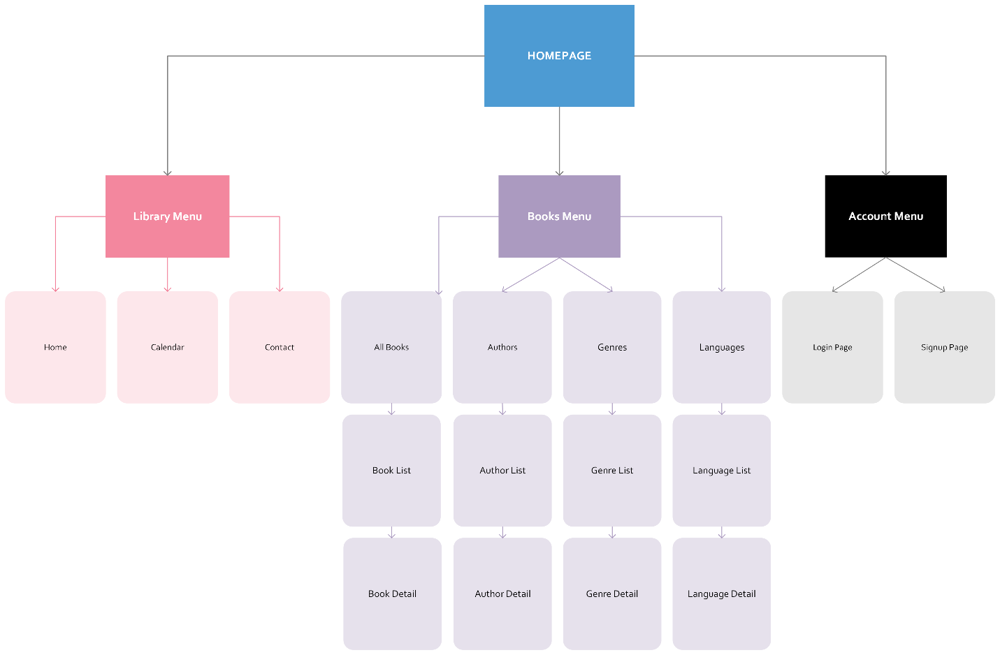

## Appendix C - Sprint Review Reports

### Sprint Review 1

Date: 10/21/22

Start time: 8:00 PM

End time: 8:30 PM

After a show and tell presentation, the implementation of the following user stories was accepted by the product owners: All.

* User Story (1): As a library member, I want to visit a simple website for my library so that I can find basic information about my library without having to visit in person.
* User Story (2): As a library member, I want to see books including author, genre, language and copies available on my library’s website so that I can plan my next book.
* User Story (3): As a library member, I want to see up-to-date information managed by library staff on my library’s website so that I can be sure the book I want is available.
* User Story (4): As a library member, I want my library’s website to have a simple home page with sidebar navigation so that I can easily find what I’m looking for.
* User Story (5): As a library member, I want my library’s website to have detailed pages for books and authors so that I can see more information when I want to.

The following ones were rejected and moved back to the product backlog to be assigned to a future sprint at a future Sprint Planning meeting.

* No user stories were rejected and moved back to the product backlog.

### Sprint Review 2

Date: 11/4/22

Start time: 8:00 PM

End time: 8:30 PM

After a show and tell presentation, the implementation of the following user stories was accepted by the product owner: All.

* Gremillion, Stephanie (13 points)
  + User Story (5 points): Deploying Django to production
  + User Story (5 points): Adding a user account home page after login
  + User Story (3 points): Update website to be more attractive (color, font, stylization, etc.)
* Jaime, Joshua (5 points)
  + User Story (5 points): Add interface for new users to create their own accounts (asking for personal information)
* Mead, Andrew (10 points)
  + User Story (5 points): As a library member, I want to be able to log into my library’s website so that what I see matches what I can do based on whether I am an employee or not.
  + User Story (5 points): As a library member, I want my library’s website to have good security so that my information is secure from the outside world.
* Navarro, Josejavier (10 points)
  + User Story (5 points): As a library member, I want to the website to have a feature where the librarians can add books and authors by filling out fields such as the name or the author of the name of the book.
  + User Story (5 points): As a library member, I want the website to have a search bar where it can allow the user to either search for the name of a book or for an author.
* Pittman, Douglas (10 points)
  + User Story (5 points): As a library member, I want to ensure that the site loads and that everything is functional.
  + User Story (5 points): As a library member, I’d like to have access to additional information on the author so that I can find other works by the author if I like the initial book that I check out.

The following ones were rejected and moved back to the product backlog to be assigned to a future sprint at a future Sprint Planning meeting.

* User Story (5 points): Disable new users from borrowing books until their new accounts have been verified (add this feature to staff accounts).

### Sprint Review 3

Project: Library Website

Attendees: (1) Gremillion, Stephanie (2) Jaime, Joshua (3) Mead, Andrew

(4) Navarro, Josejavier (5) Pittman, Douglas

Date: 11/18/22

Start time: 9:00 PM

End time: 9:30 PM

The product owner accepted the following user stories as done after presentation:

* Gremillion, Stephanie
  + User Story 50: Navigation bar at top of page
  + User Story 52: Add images to author and book detail pages
* Jaime, Joshua
  + User Story 42: Disable new users from borrowing books until their new accounts have been verified by Staff member.
* Mead, Andrew
  + User Story 47: Allow user to view genres
  + User Story 48: Allow user to view languages
* Navarro, Josejavier
  + User Story 51: Have the search bar also accept keywords and author names
* Pittman, Douglas
  + User Story 40: Add book recommendations to the book detail page (recommending same author/genre)

The following user stories are not done and went back to the product backlog:

* + User Story 39: Add book of the day/collections and books by genre on homepage
  + User Story 44: Enable librarians to disable user account borrowing feature
  + User Story 38: Allow users to leave reviews on books

### Sprint Review 4

Date: 12/2/22

Start time: 9:00 PM

End time: 9:30 PM

The product owner accepted the following user stories as done after presentation:

* Gremillion, Stephanie
  + User Story 59: Website needs to be tested for accessibility
  + User Story 54: Create an event calendar
* Jaime, Joshua
  + User Story 49: Add a contact system for librarians and users.
* Mead, Andrew
  + User Story 39: Add book of the day collection
  + User Story 58: Add contact information to website
* Navarro, Josejavier
  + User Story 43: Users can reserve and borrow books from the library
* Pittman, Douglas
  + User Story 38: Allow users to leave reviews on books

The following user stories are not done and went back to the product backlog:

* + User Story 46: Add children’s section to website
  + User Story 53: Replace pagination with "load more" button
  + User Story 45: Books should have different format options

## Appendix D - User Manuals, Installation/Maintenance Document, Shortcomings/Wishlist Document and other documents

### User Manual

#### 1. General Information

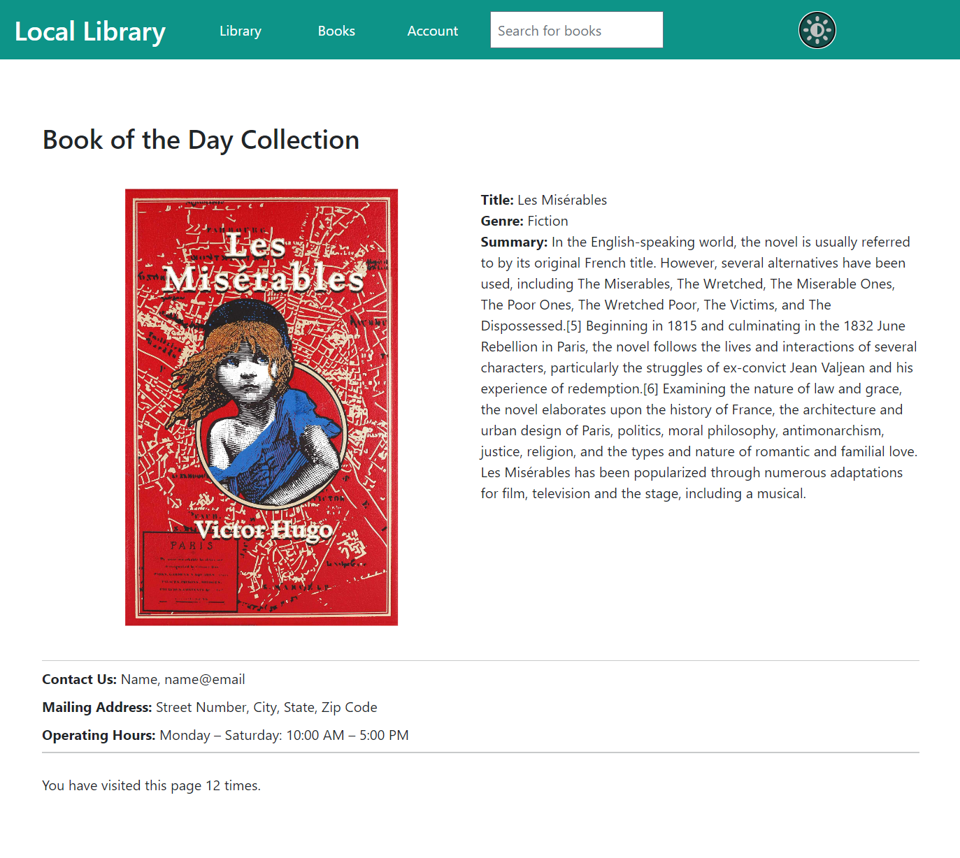The Local Library Website is designed and developed to be used by Local branch of Library. (Figure 1-1) It has the full functionality of a library website, including viewing the library’s catalog of books, borrowing books from the library, viewing library events and information, and contacting the library staff. The website is developed to be used by a wide variety of clients. It is designed with simplicity and accessibility in mind.

Figure 1‑1   
Library Home Page

#### 2. User Accounts

The website allows the creation and use of several types of user accounts: administrative, staff, and library user. The administrative accounts are for those who do maintenance on the website (such as information technology (IT) staff). The staff accounts are for those who upkeep the library (such as librarians). Lastly, the library user accounts are for the patrons of the library. Each type of account has different features that they are allowed to do.

##### 2.1 Account Creation

Regardless of the type of account, account creation can be done in one of two ways: via the admin page or via the library website.

###### 2.1.1 Account Creation via the Admin Page

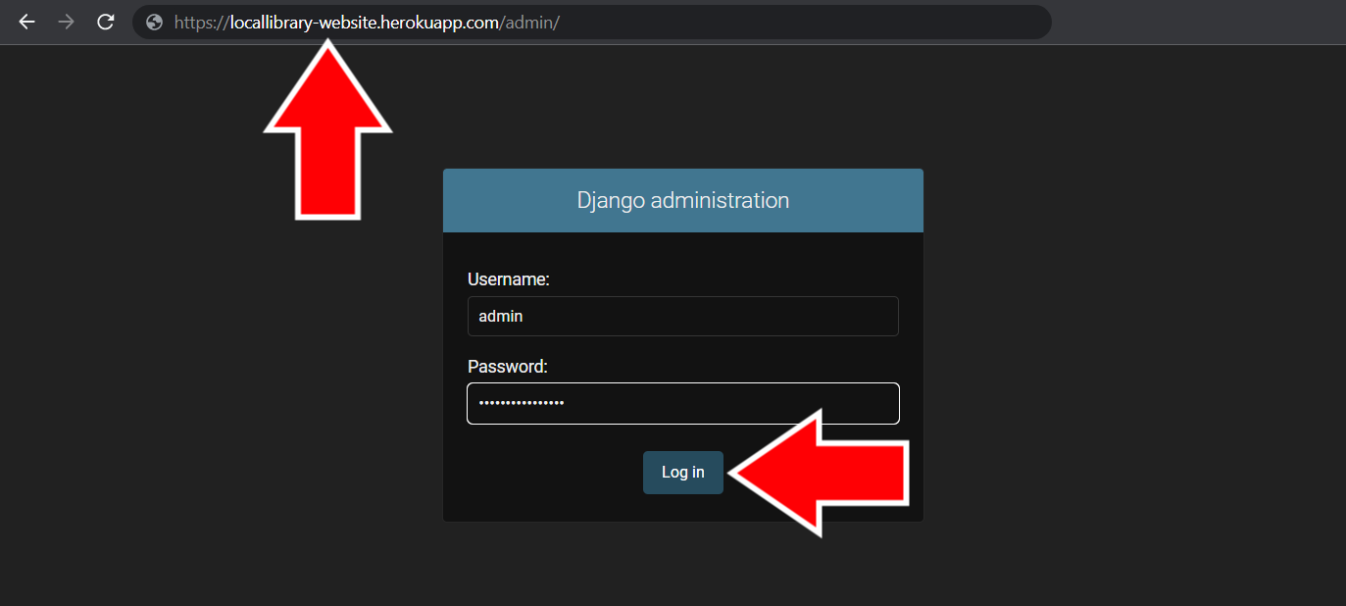**Administrative** or **Staff** accounts can create new user accounts from the admin page of the website. Below are the steps to create an account on the admin page:  
  
1) In your website browser, go to the admin page at [librarywebsite].com/admin and login with an administrative or staff account. (Figure 2-1)

Figure 2-1   
Admin Page Login

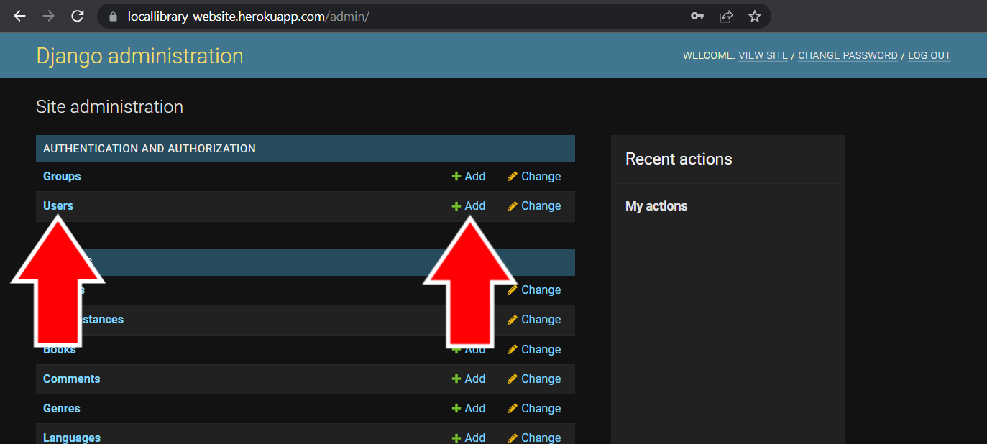2) Once logged in, you’ll be taken to the **Site Administration** page. Underneath the **Authentication and Authorization** category, either click on **Users** on the left or click on the **+ Add** button on the right side next to **Users**. (Figure 2-2) If you pressed the **+Add** button, skip to step 4.

Figure 2-2 Site Administration Page

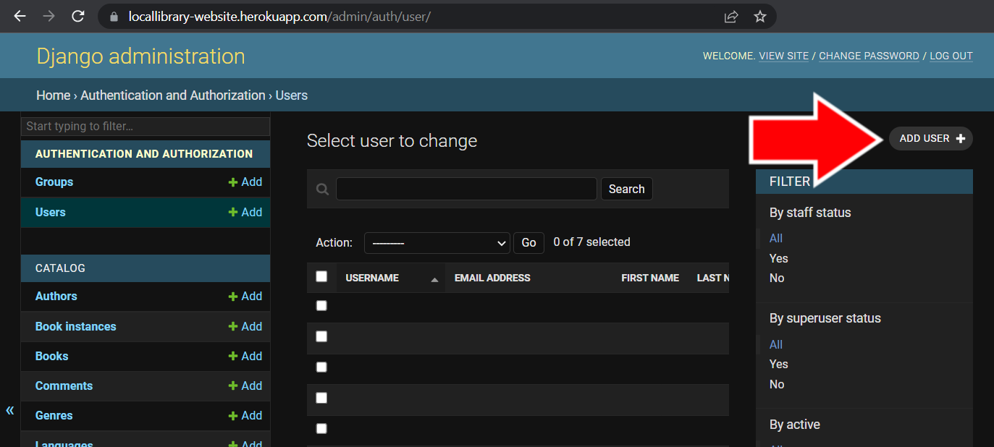3) Once on the **User** page, click the **Add User +** button in the top right corner to start creating a user account. (Figure 2-3)

Figure 2-3   
Admin Users Page

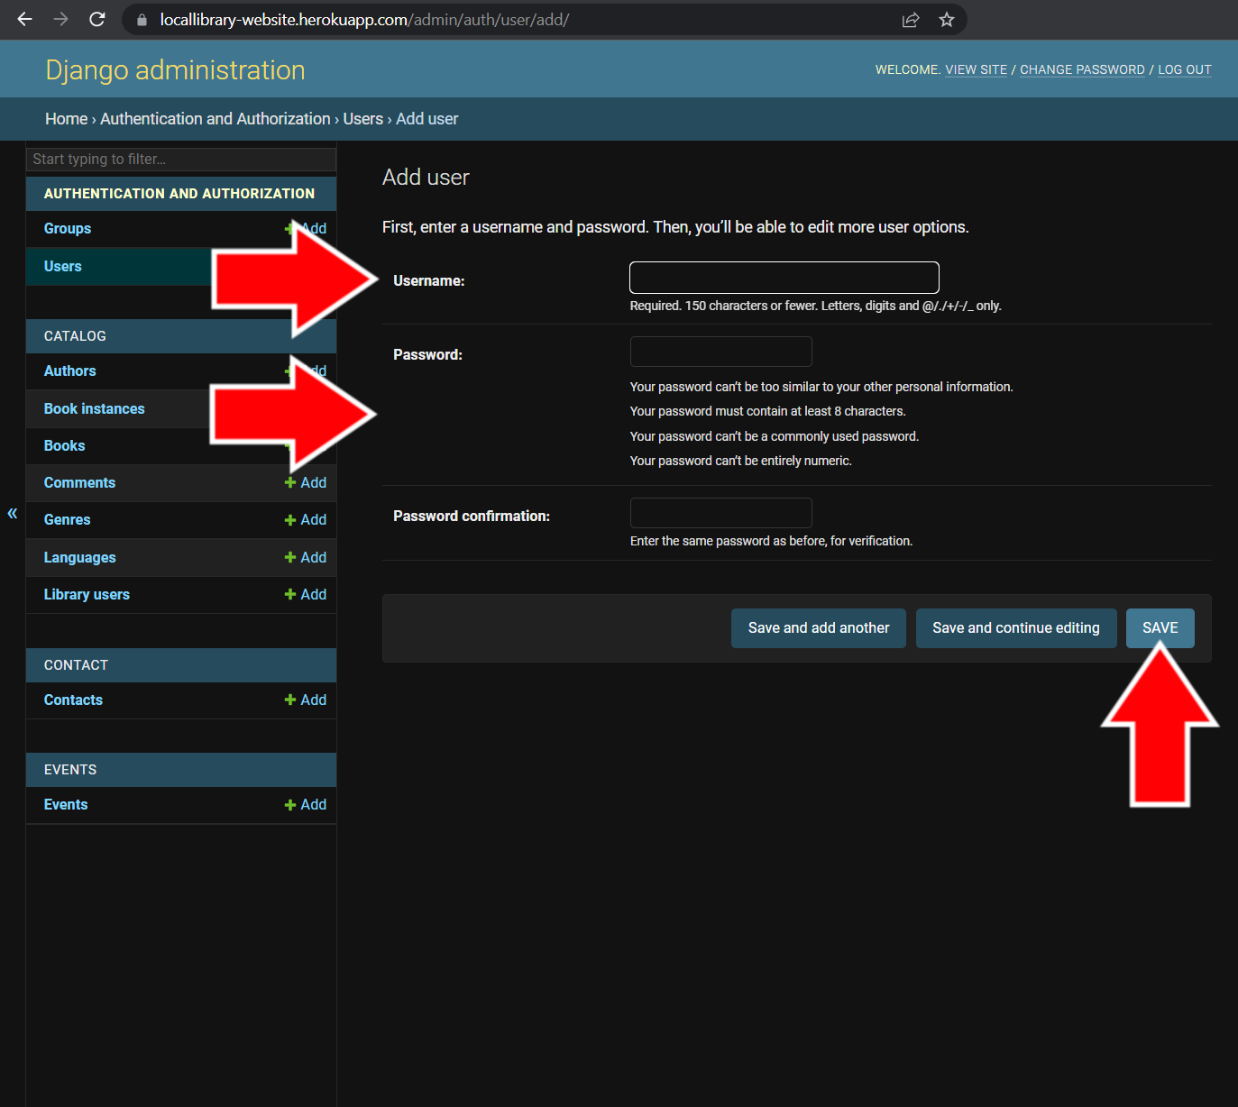4) On the user creation page, create the username and add a secure password. (Figure 2-4) Be sure to create a secure password that doesn’t include the username, contains at least 8 characters, isn’t commonly used, and contains both numbers and letters.

When finished, click the **Save** button at the bottom right. (Figure 2-4) After creating an account, you’ll be able to add more information such as name and e-mail.

Figure 2-4   
User Account Creation Page

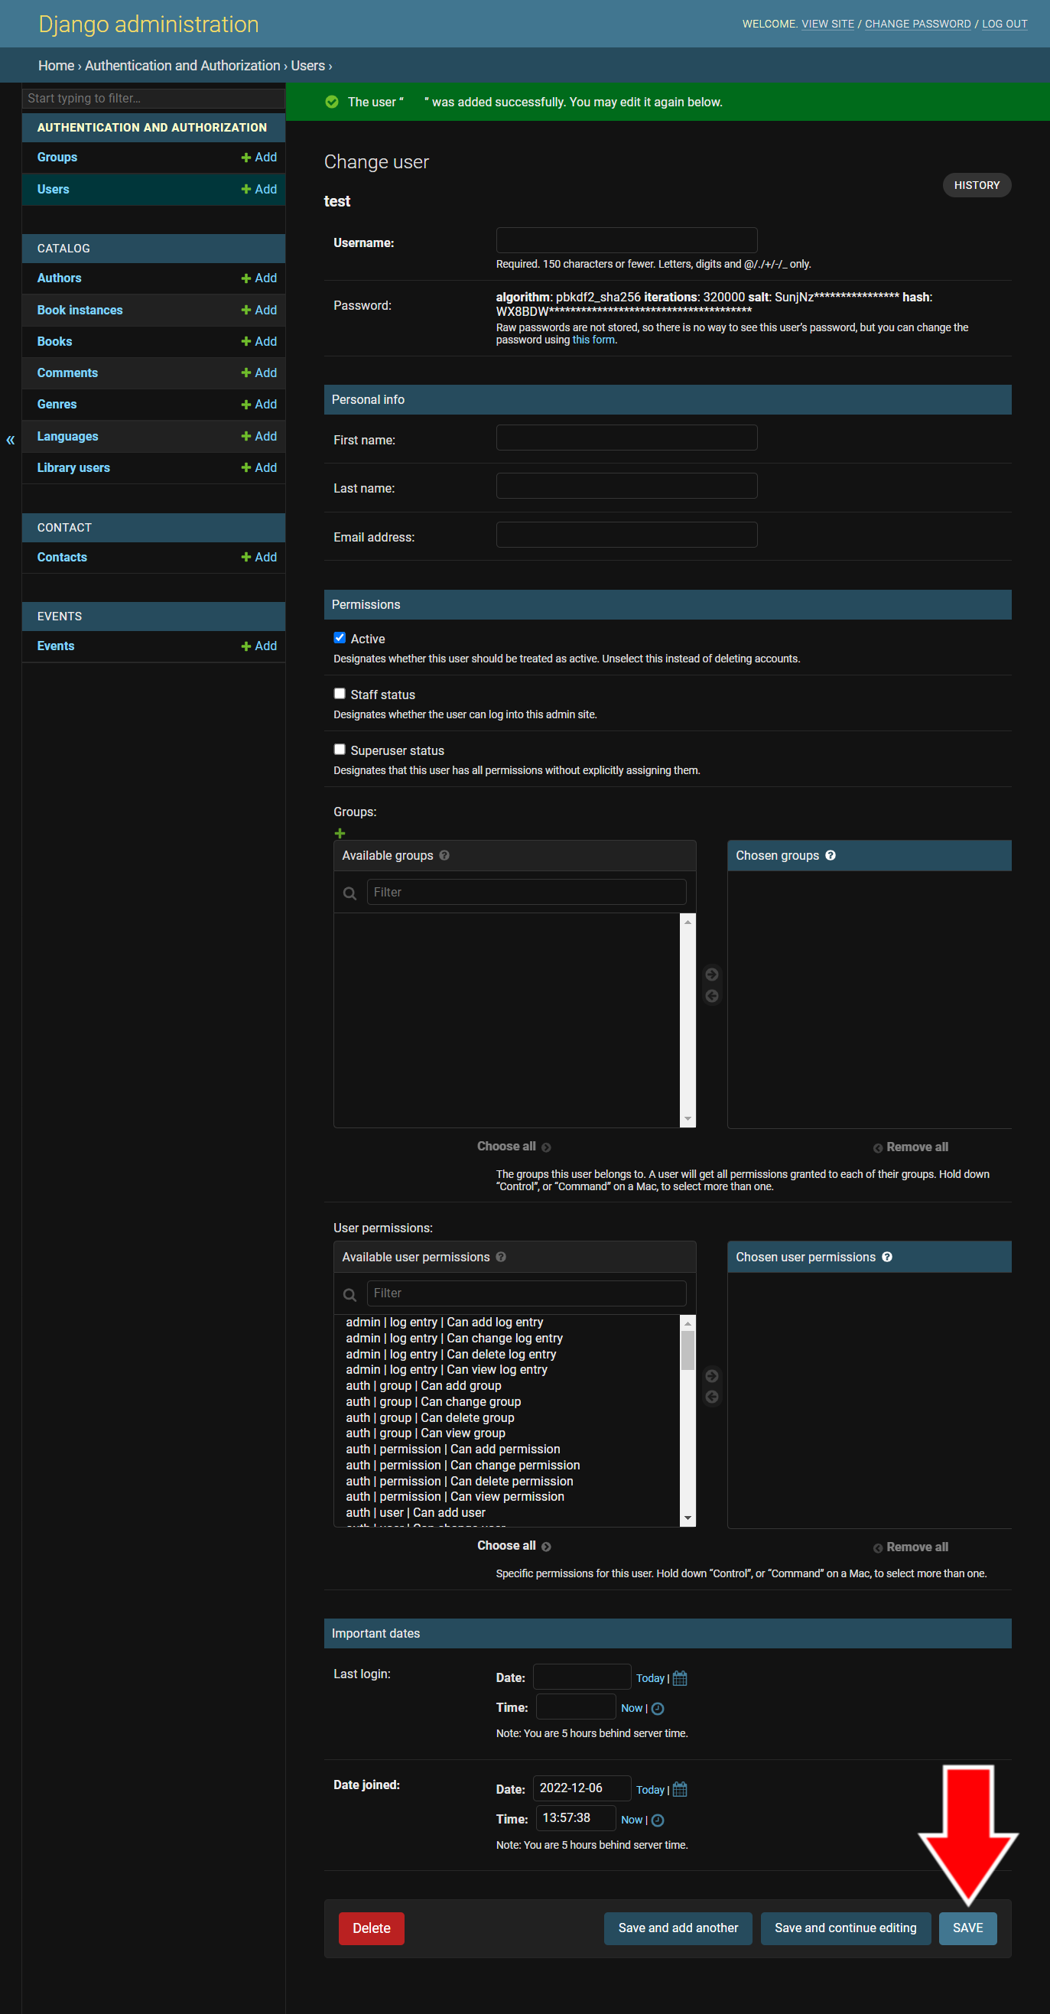5) Upon successful account creation, you’ll be taken to the **Change user** page, (Figure 2-5) where you can fill in the details of the account.

On this page, you can change the account’s username and password.

Under **Personal Info**, add the user’s first name, last name, and e-mail address.

Under **Permissions**, you can set the permissions for the account. The **Active** status indicates whether or not the account can be used or if the user is “active”. The **Staff status** option indicates whether or not the account is for a staff member’s use. This selection gives the account all of the permissions of a staff account (renewing books, editing books, etc.; see section 3 for more information). The **Superuser status** option indicates whether or not the account is for use by a “superuser,” or someone who is in charge of maintaining the website (such as IT staff).

**Groups** are sets of permissions you can assign to specific accounts. **User permissions** are how the account can interact with features of the website and admin page. It is recommended that you assign accounts to **Groups** instead of setting individual user permissions.

Once finished setting up the user account and filling in the information, press the **Save** button in the bottom right corner.

Figure 2-5   
Change User Page

###### 2.1.2 Account Creation via the Library Website

Anyone can initiate the creation of an account via the Library Website. Below are the steps to create an account on the Library Website:

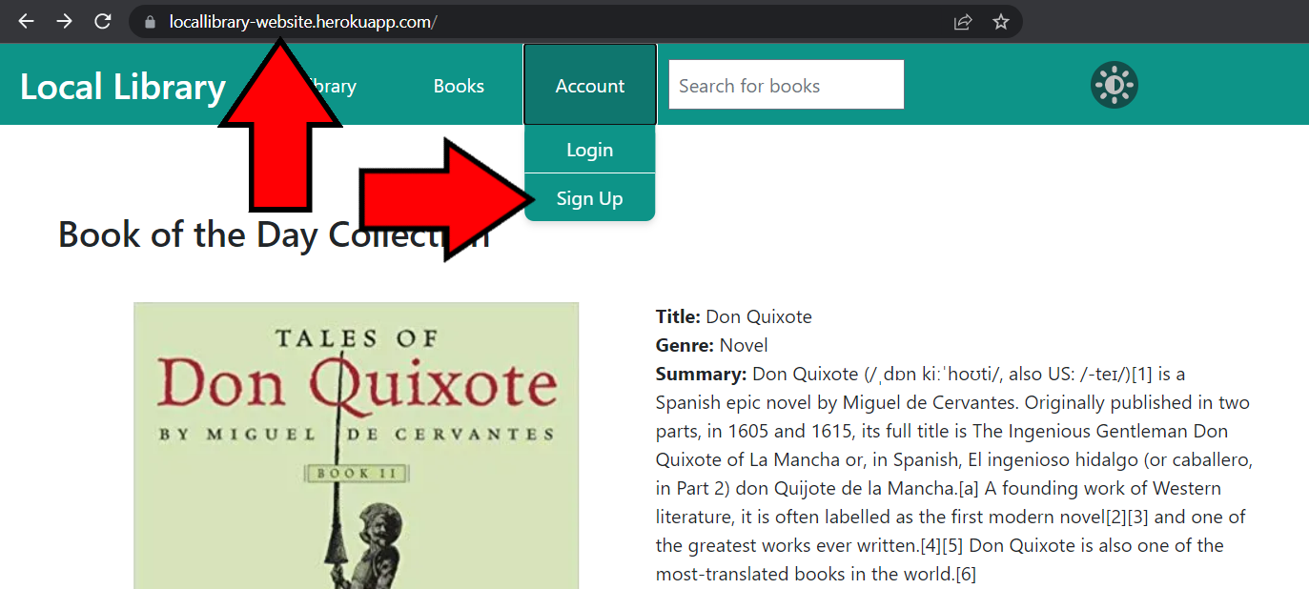1) In your web browser, go to the library website at [librarywebsite].com. Once on the Library Website home page, click on the **Account** drop-down menu and select **Sign Up**. (Figure 2-6) This will take you to the account sign up page.

Figure 2-6   
Library Home Page Showing Sign Up Button

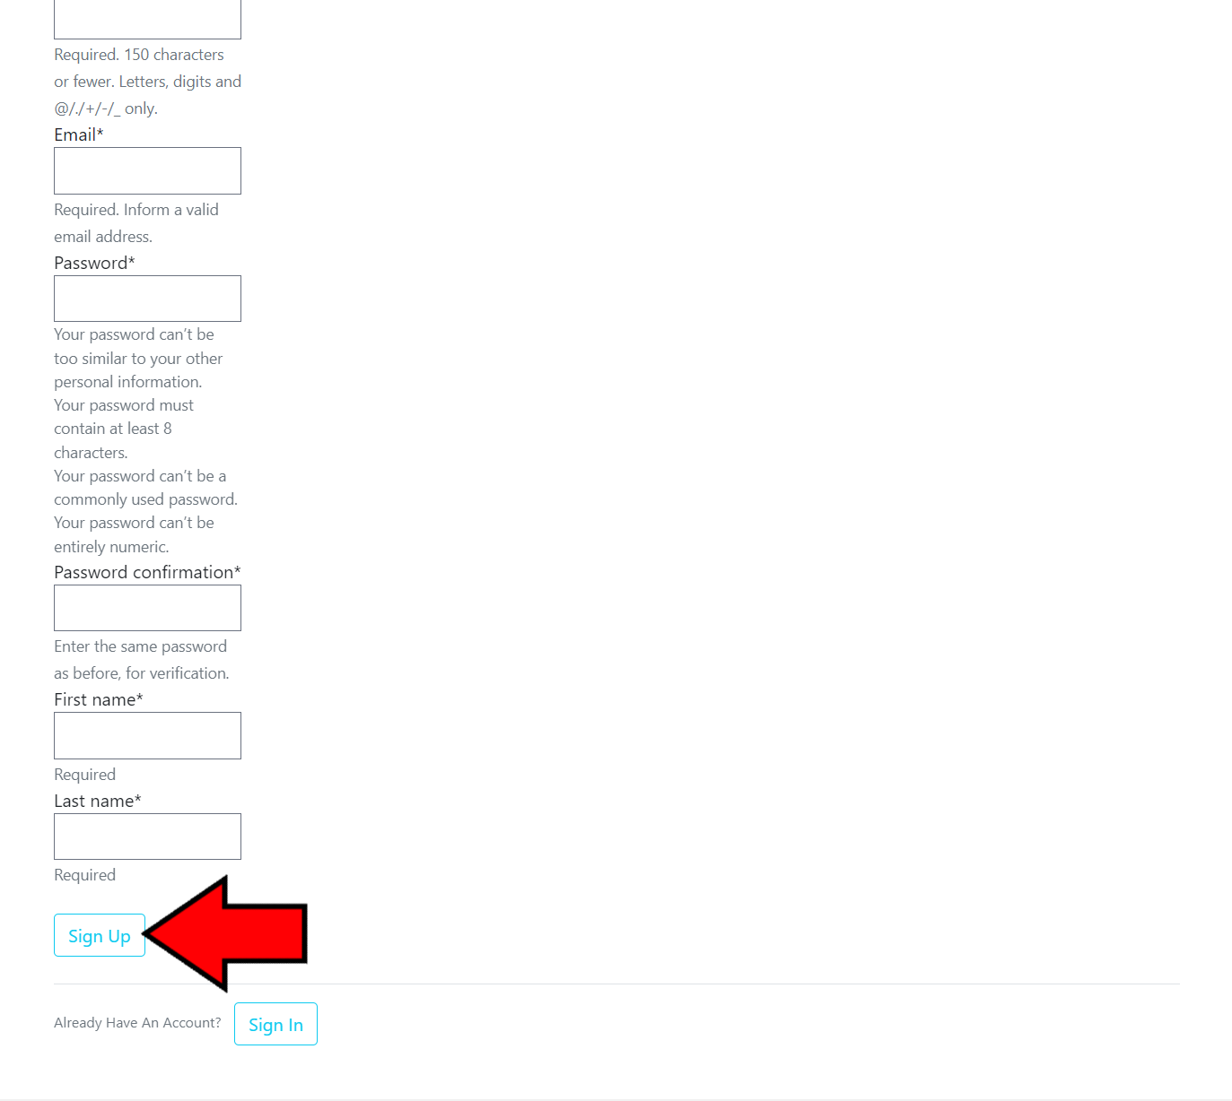2) You’ll be taken to the **Join Today** account sign up page. Here, you’ll be able to enter the account information such as username, e-mail, password, first name, and last name.

When creating a password, be sure to not include the username in the password, make sure it’s at least 8 characters long, don’t use a common password, and be sure to use letters and numbers. Once all of the information has been entered, press the **Sign Up** button at the bottom of the page. (Figure 2-7) A user account will be created and become inactive.

Figure 2-7  
 Join Today Page

Once an account has been created, a librarian needs to set the account to active in order for the user to login to the account (see section 2.1.1, number 5 for more information).

##### 2.2 Editing an Account

Once a user account has been created, the information and permissions on the account can be changed by an administrative or staff account on the admin page. Below are the steps the change a user account’s information:

1) In your website browser, go to the admin page at [librarywebsite].com/admin and login with an administrative or staff account. (Figure 2-8)

Figure 2-8   
Admin Page Login

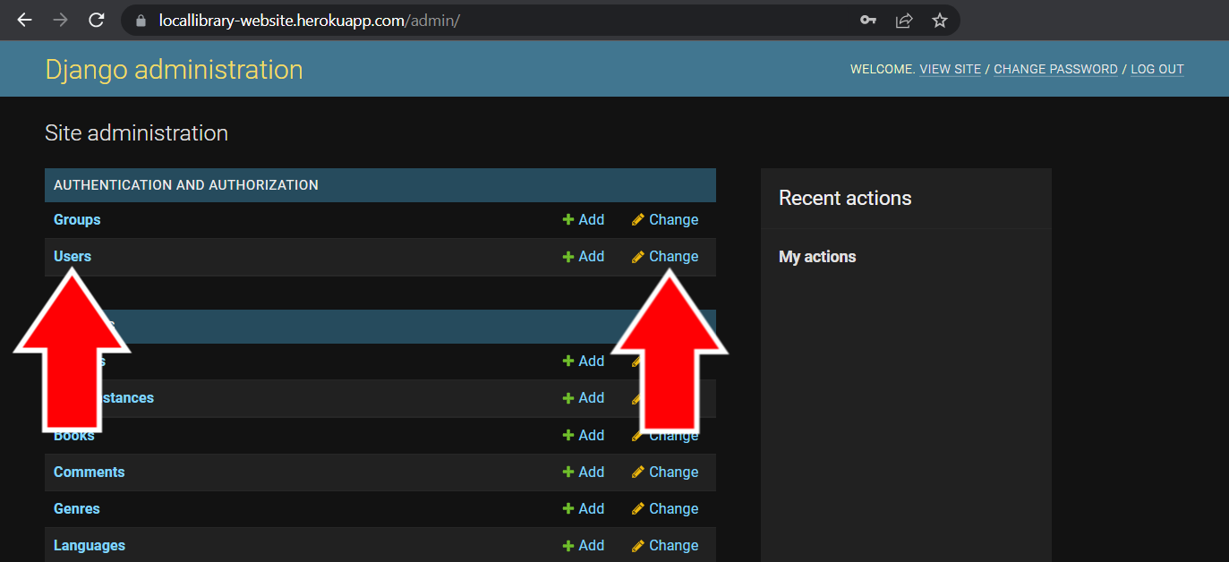2) Once logged in, you’ll be taken to the **Site Administration** page. Underneath the **Authentication and Authorization** category, either click on **Users** on the left or click on the **Change** button on the right side next to **Users**. (Figure 2-9)

Figure 2-9   
Site Administration Page

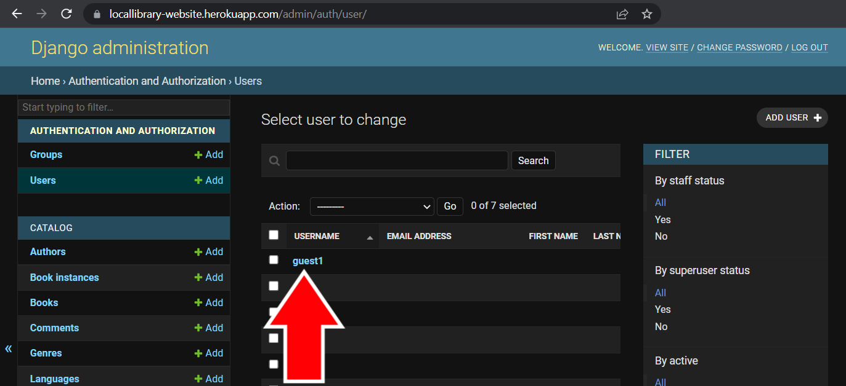3) Once on the **Users** page, select the user whose information you want to change. (Figure 2-10) You’ll be taken to the **Change user** page (see section 2.1.1, number 5 for more information). Here, you will be able to change the user’s username, password, name, e-mail, permissions group, and other information.

Figure 2-10 Admin Users Page

##### 2.3 Permissions

The permissions on user accounts are the allowed features that account can interact with. It is important to make sure each account has the correct permissions.

###### 2.3.1 Permission Types

Permissions are divided into groups based on which feature of the website they interact with. The following is a list of features currently available for the Local Library Website:

**Admin, Auth,** **Content Types, Sessions** – These permissions are for administrative purposes and should only be given to high level staff or account users (such as IT staff or those who are responsible for maintaining the website).

**Catalog** – These permissions are for changing the catalog and library user permissions.

**Library User** – The library user subcategory is given to accounts who are allowed to borrow books from the library.

**Other Subcategories** – All of the other catalog subcategories are for changing book information (books, copies, authors, genres, languages, and comments).

**Contact** – These permissions are for interacting with the messages received from the **Contact Page** form.

**Events** – These permissions are for changing event details on the **Calendar Page**.

###### 2.3.2 Creating Group Permissions

Group permissions make it easy to keep track of which account has which permissions by grouping the permissions based on what kind of access certain types of user accounts get. Below are the steps to creating a group:

1) In your website browser, go to the admin page at [librarywebsite].com/admin and login with an administrative or staff account. (Figure 2-11)

Figure 2-11   
Admin Page Login

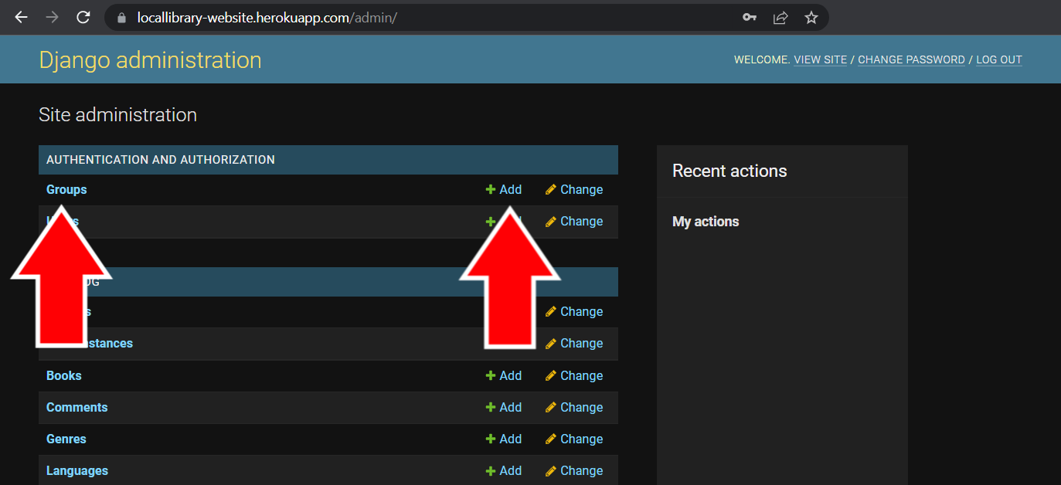2) Once logged in, you’ll be taken to the **Site Administration** page. Underneath the **Authentication and Authorization** category, either click on **Group** on the left or click on the **+ Add** button on the right side next to **Groups**. (Figure 2-12) If you pressed the **+ Add** button, skip to step 4.

Figure 2-12 Site Administration Page

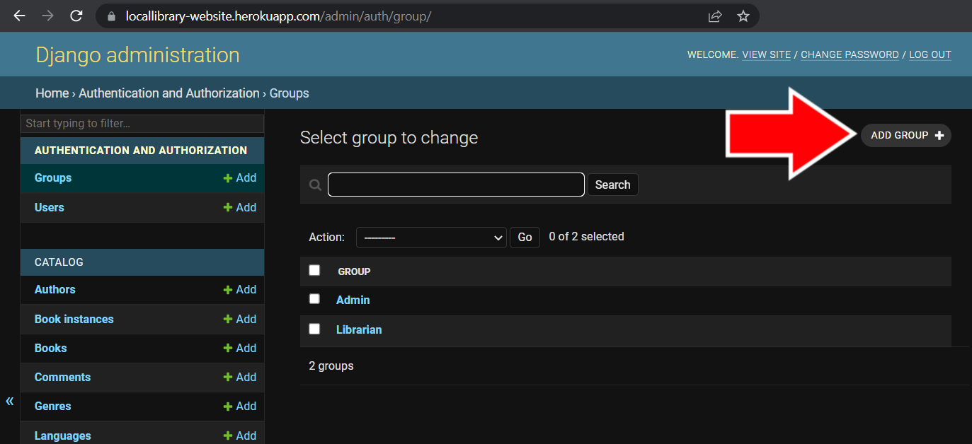3) Once on the **Groups** page, click the **Add Group +** button in the top right corner to start creating a permissions group. (Figure 2-13)

Figure 2-13   
Admin Groups Page

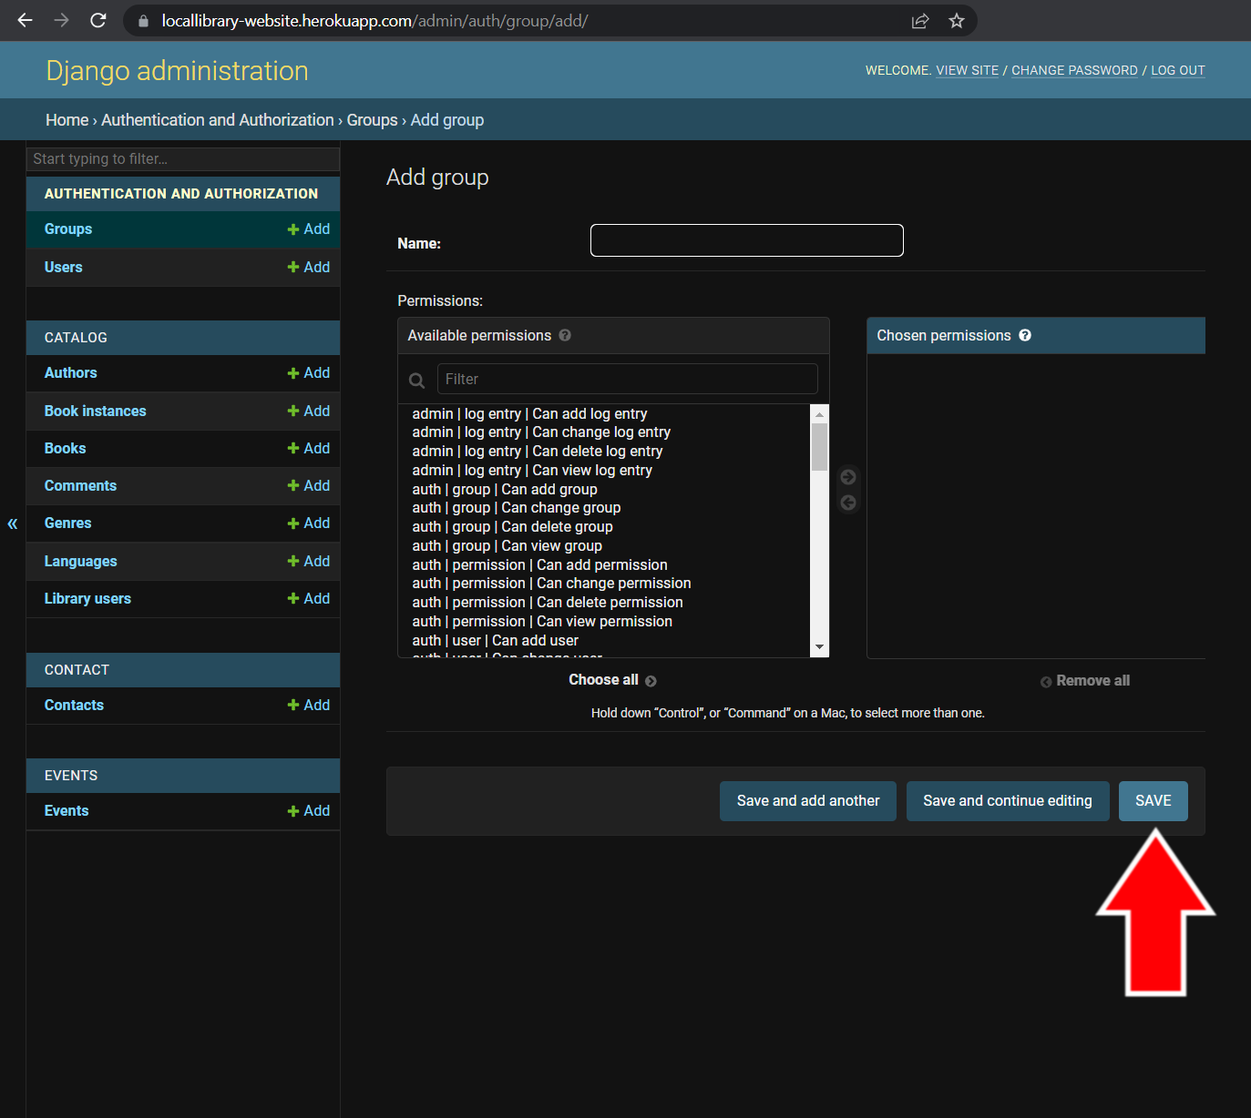4) On the **Add group** page, you can start adding permissions to your group. Give your group a meaningful name so you know which accounts it should apply to (ex: Librarian can edit catalog).

To add permissions to the group, select the permissions on the left side under **Available permissions** and click the arrow that points to the right between **Available permissions** and **Chosen permissions**. You can highlight multiple permissions and add them. To take away permissions, select the permissions you want to remove underneath **Chosen permissions** and click the left arrow between **Available permissions** and **Chosen permissions**.

Once finished changing permissions, click the save button at the bottom of the page. (Figure 2-14)

Figure 2-14 Add Group Admin Page

#### 3. Catalog

The catalog is the section of the library website that holds all of the information for the books and calendar. It has several interactive features, discussed in the following sections.

##### 3.1 Categories

The books in the catalog are separated into several categories. Library users can view books according to each category.

###### 3.1.1 Books

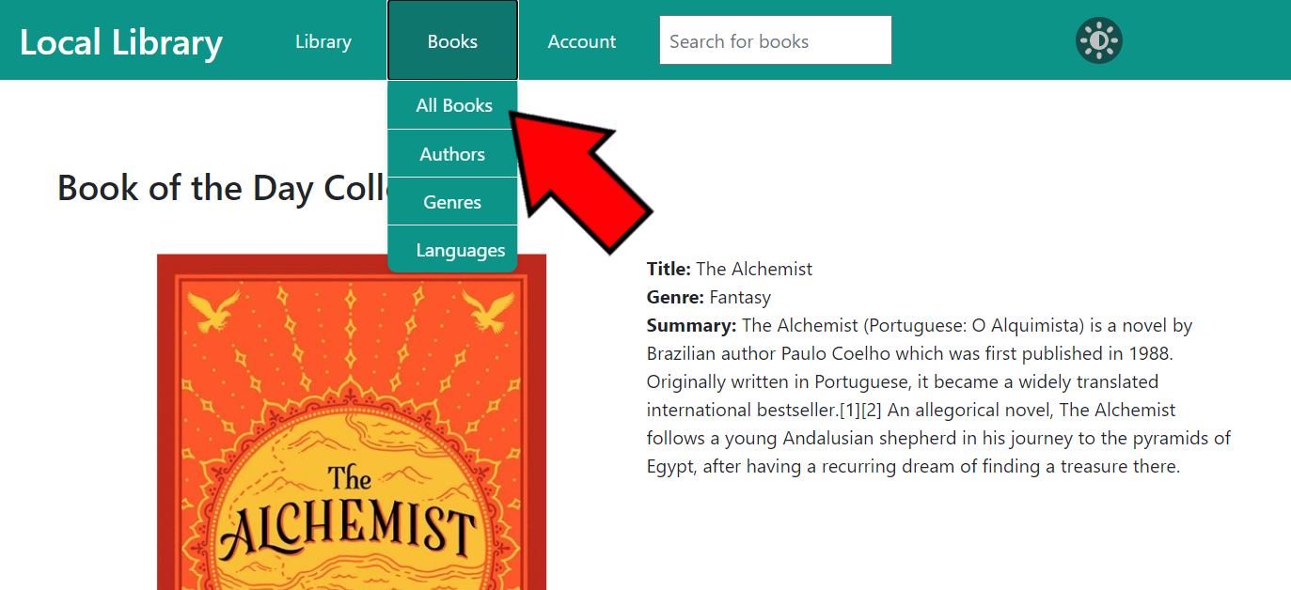The default category for viewing all of the books in the catalog is sorted by title name. To view all of the books in the catalog, click the **Books** button on the navigation bar to view the catalog drop-down menu and click on **All Books**. (Figure 3-1)

Figure 3-1   
Library Home Page Show All Books Button

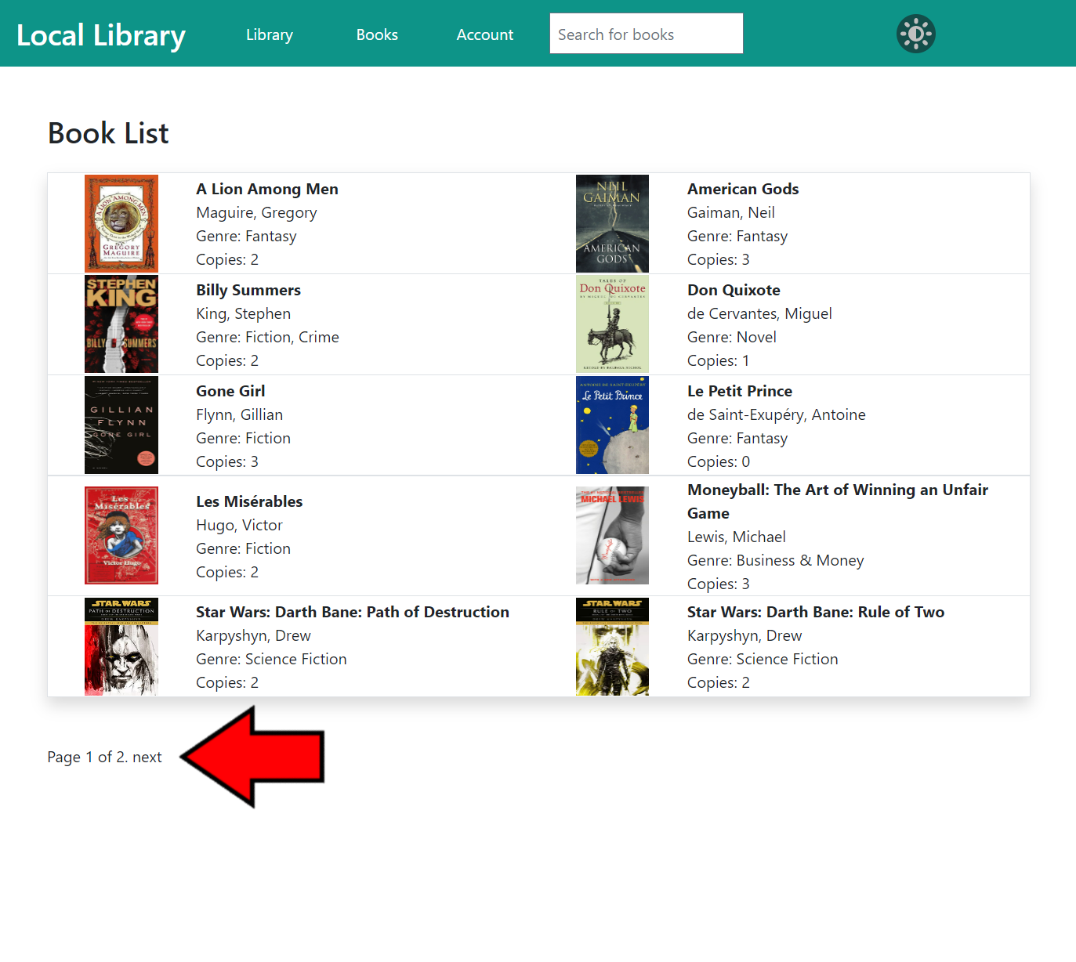This will bring you to the **Book List** page, where you can browse all of the books in the catalog. Next to each book you can view the title, author, genre, and how many copies are in the library. To view more information about the book or author, simply click on the name and you will be brought to that book or author’s detail page.

The book list is separated into groups of 10 on each page. Press the **Next** or **Previous** buttons at the bottom of this page to browse through the pages of books. (Figure 3-2)

Figure 3-2   
Book List Page

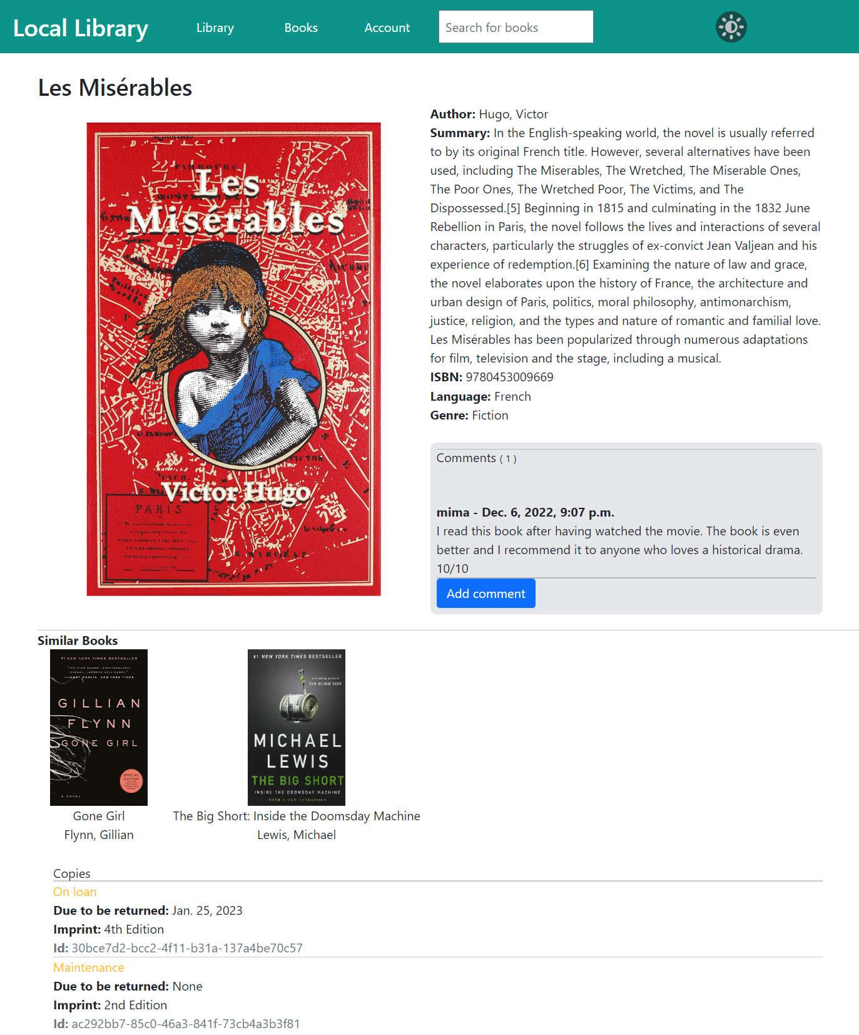Clicking on a book title brings you to the book’s detail page, which gives information on the book including title, author, summary, ISBN, language, genre, similar books (see section 3.3.2 for more information), copies, and comments that library users have left about the book. (Figure 3-3)

Figure 3-3   
Book Detail Page

###### 3.1.2 Authors

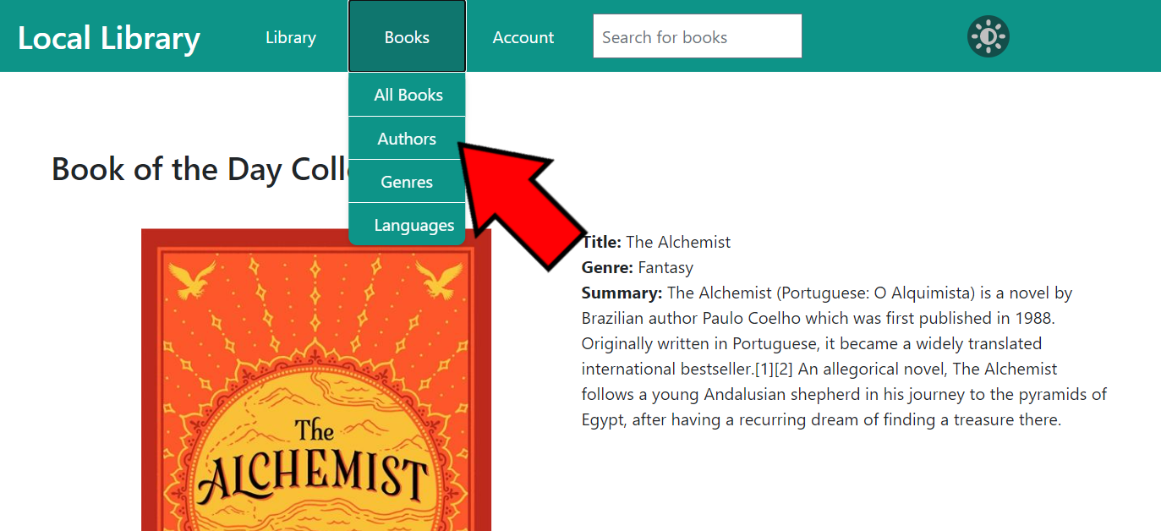Users can view all of the authors of the books in the library catalog by clicking the **Books** button on the navigation bar to view the catalog drop-down menu and clicking on **Authors**. (Figure 3-4)

Figure 3-4   
Library Home Page Showing Authors Button

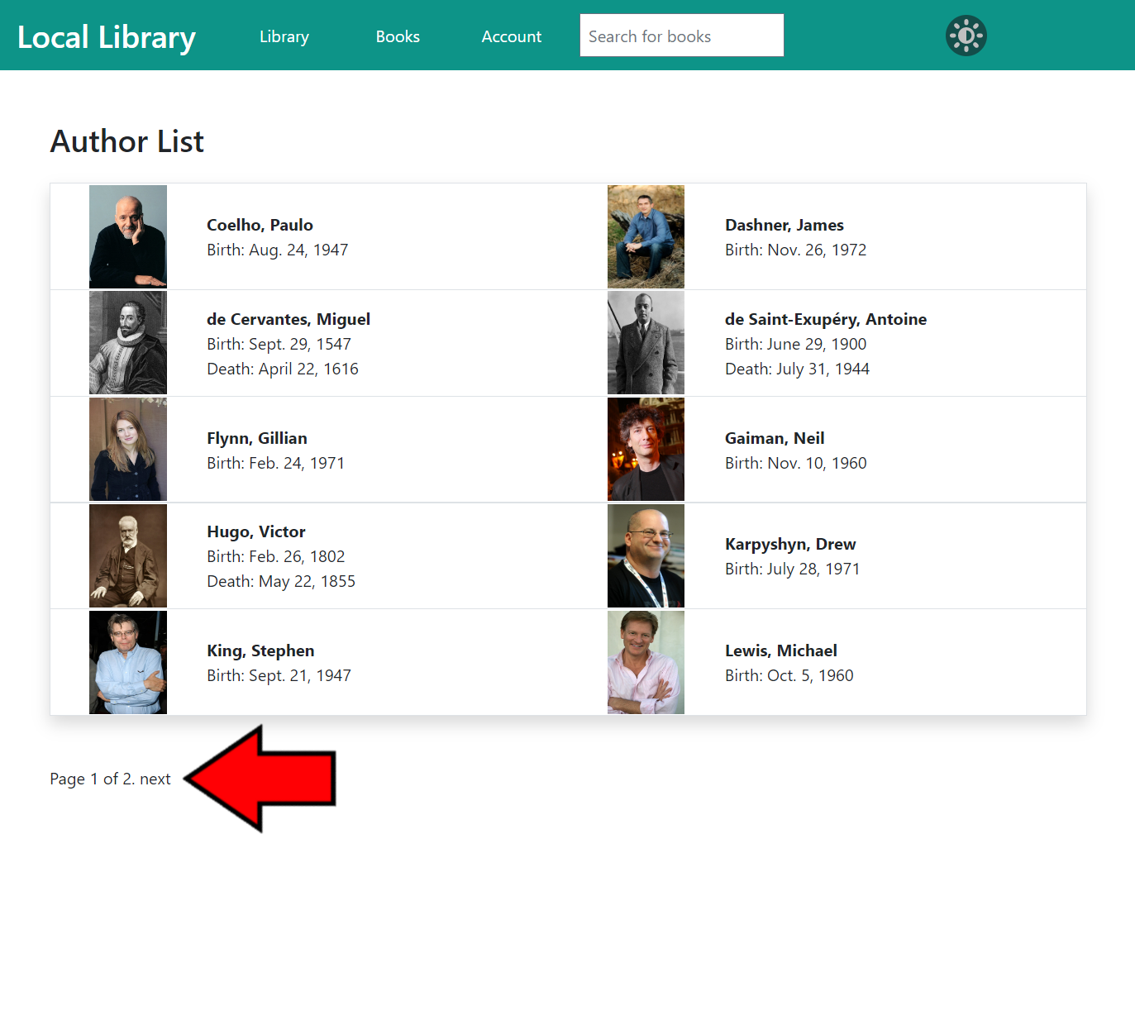This will bring you to the **Author List** page, where you can browse all of the authors of the books in the catalog. Next to each author you can view their name, date of birth, and date of death (if applicable). To view more information on an author, you can click on their name and be taken to their author detail page.

The author list is separated into groups of 10 on each page. Press the **Next** or **Previous** buttons at the bottom of this page to browse through the pages of authors. (Figure 3-5)

Figure 3-5  
Author List Page

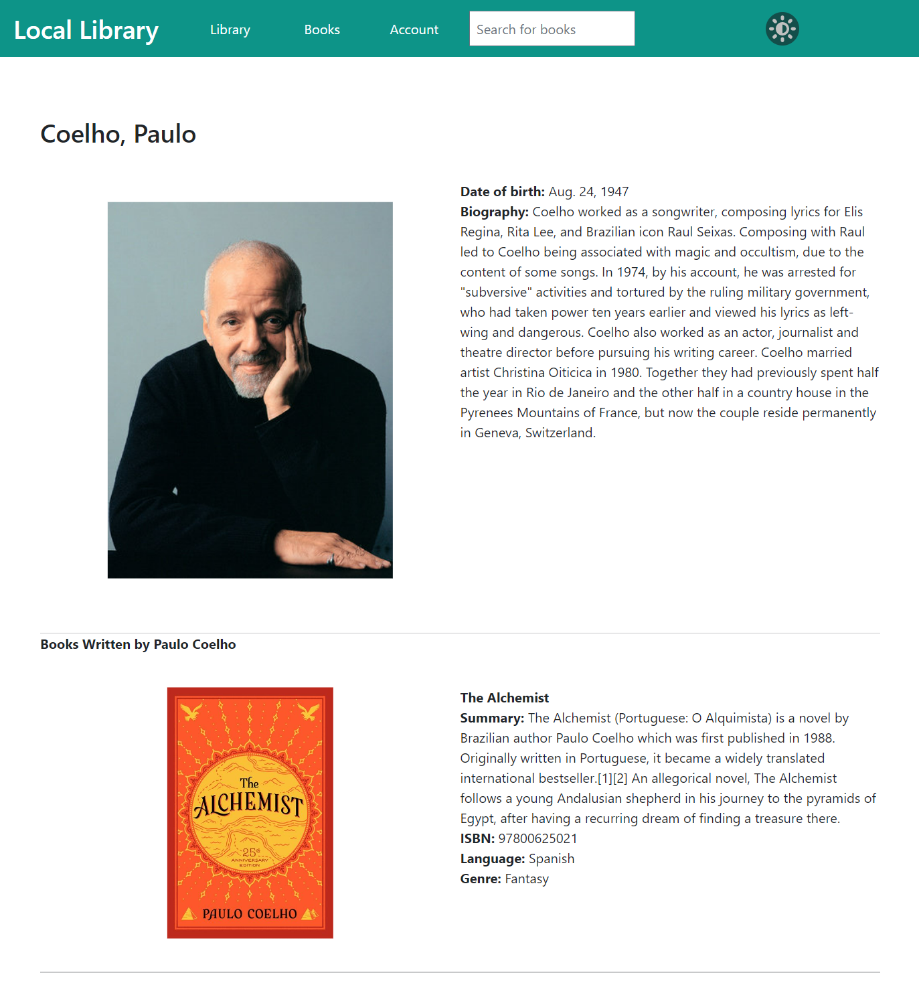Clicking on an author’s name brings you to the author’s detail page, (Figure 3-6) which gives information on that author including name, date of birth, date of death (if applicable), a small biography, and any books written by that author that are in the library’s catalog.

Figure 3-6  
Author Detail Page

###### 3.1.3 Other Categories

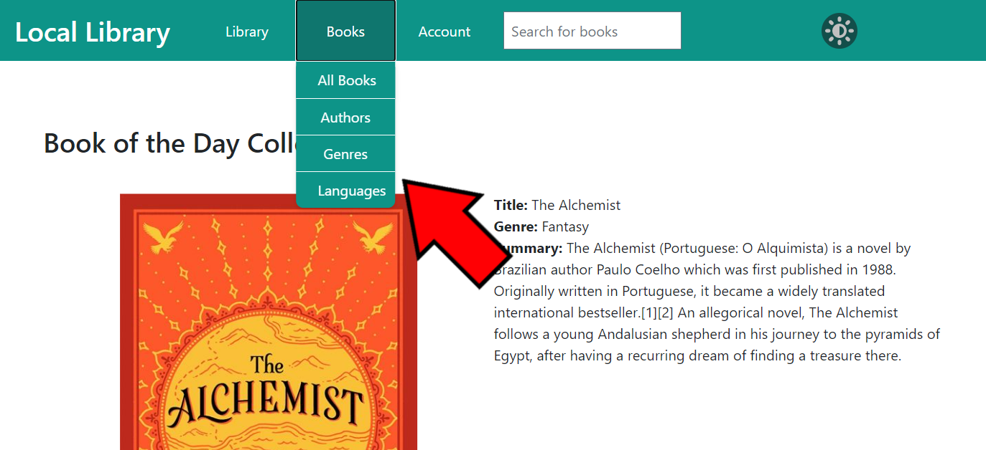Users can view all of the other categories of the books in the library catalog by clicking the **Books** button on the navigation bar to view the catalog drop-down menu and clicking on the appropriate category (either **Genre** or **Language**). (Figure 3-7)

Figure 3-7   
Library Home Page Showing the Other Category Buttons

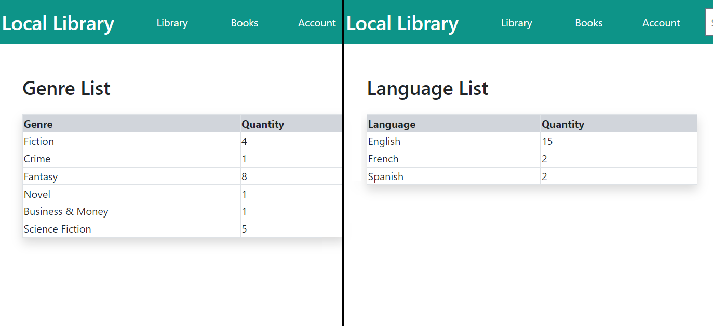This will bring you to the category list page where you can see a list of subcategories and the quantity of books in each subcategory. (Figure 3-8) If you click on **Genre**, you will see a list of all of the genres of books in the library catalog. If you click on **Language**, you will see a list of all of the languages of books in the library catalog.

Figure 3-8 Category List Pages

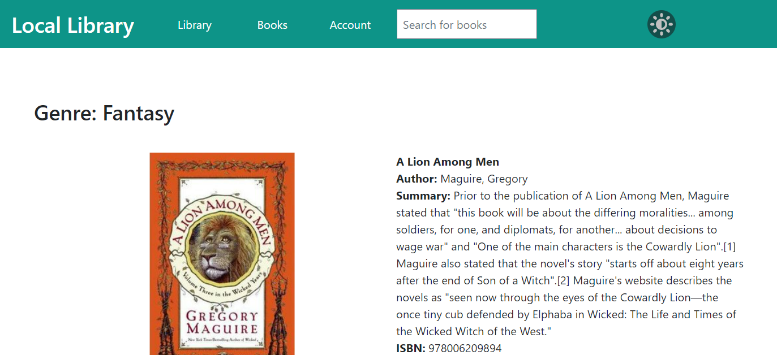   
Clicking on a genre or language will bring you to a list page of all of the books in that subcategory. (Figure 3-9) The list gives details of each book, including title, author, summary, ISBN, and any other category. To view more information about the book or author, you can click on its name and you will be brought to the detail page.

Figure 3-9 Subcategory List Page

##### 3.2 Search Bar

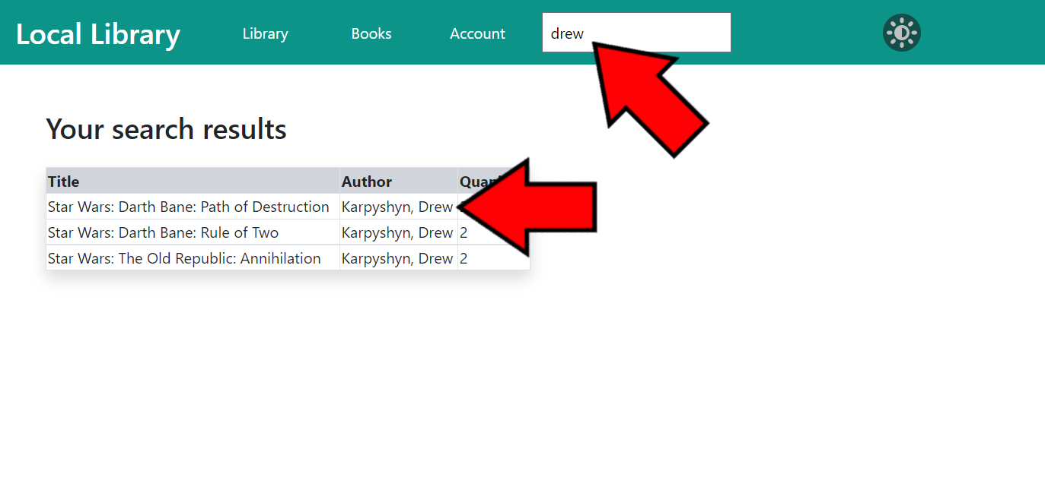On the navigation bar on each page of the library website is a **search bar**. The search bar allows users to search for books using keywords and will display a list of books that match those keywords. (Figure 3-10) The keywords are compared to the books’ titles, authors’ names, and languages.

Figure 3-10 Search Bar Results Page

##### 3.3 Other Catalog Features

The catalog on the library website hosts various other features, including a book of the day collection and similar book recommendations, detailed in the following sections.

###### 3.3.1 Book of the Day Collection

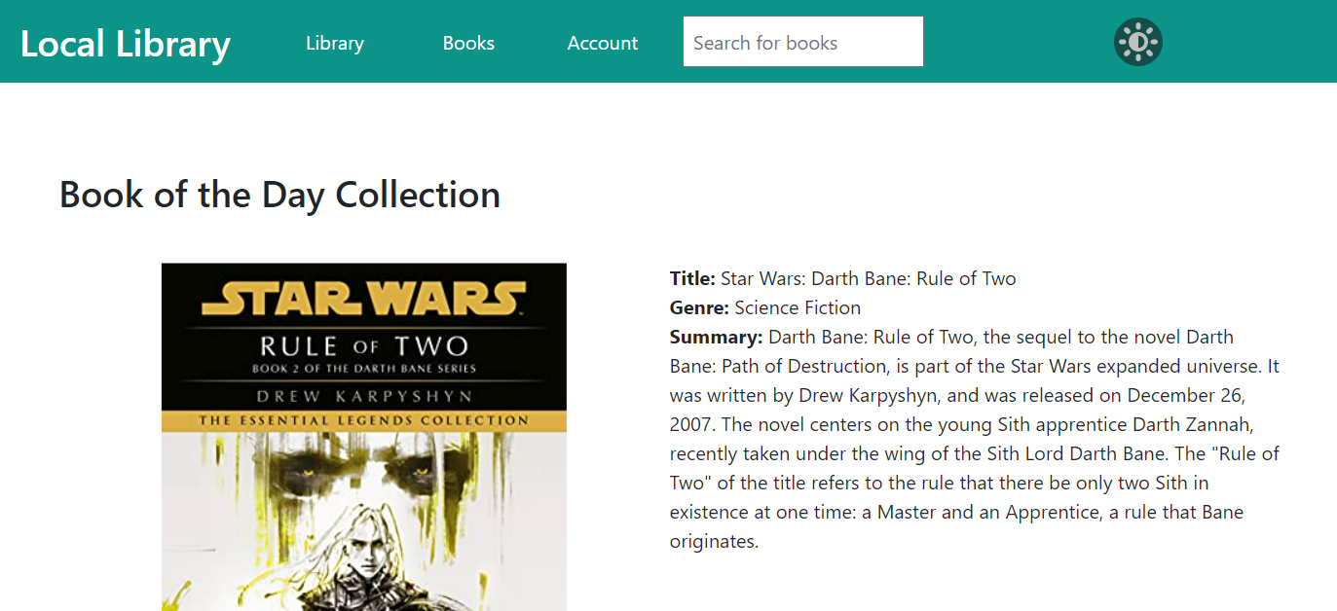On the library website’s home page is a **Book of the Day Collection**. (Figure 3-11) The book in this section changes on each visit and gives users a preview of what kind of books are in the library’s catalog. If you want to view more information about the book of the day, you can click on the title of the book to be brought to the book’s detail page.

Figure 3-11 Library Home Page Showing Book of the Day Collection

###### 3.3.2 Similar Book Recommendations

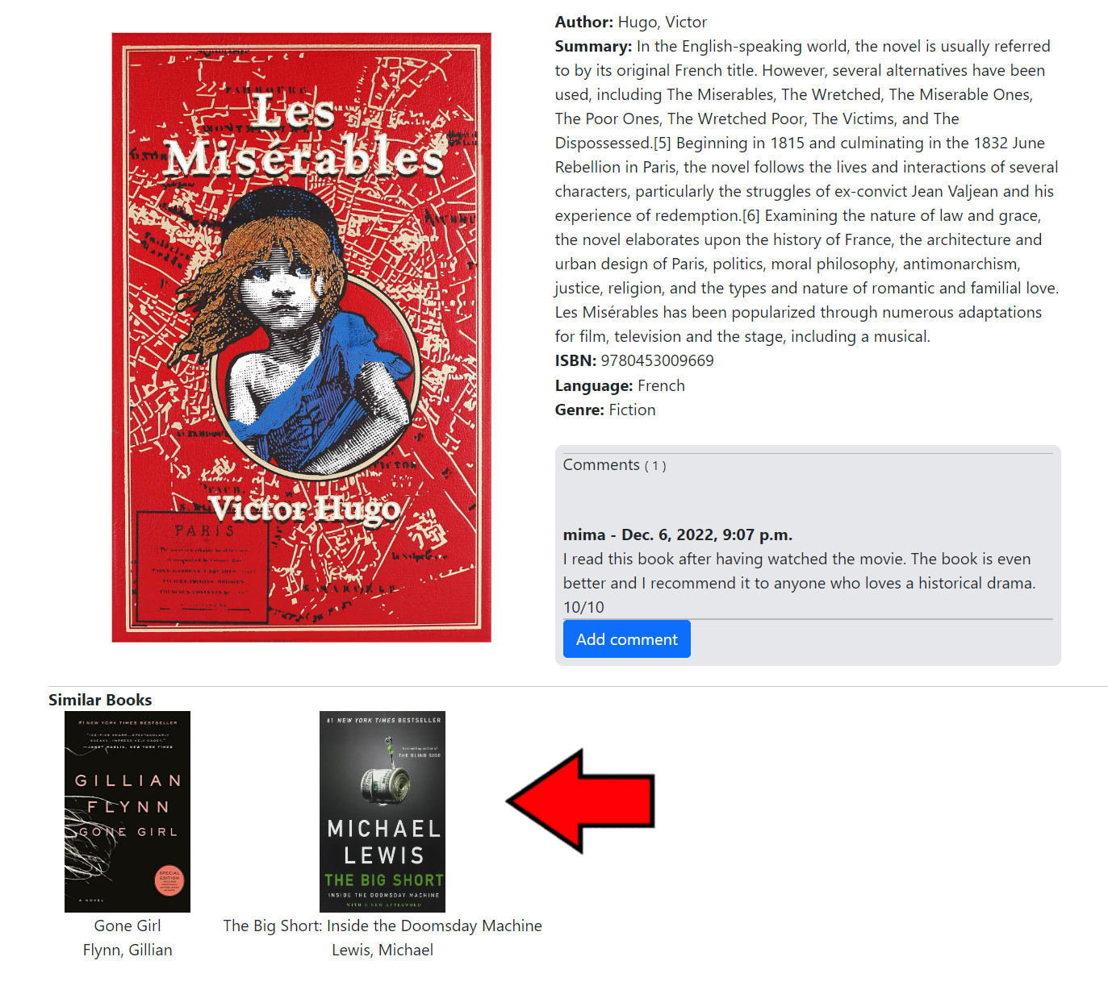On each book detail page in on the library website is a section of **similar book recommendations**. (Figure 3-12) These books share similar characteristics, such as author, genre, or language.

Figure 3-12  
Book Detail Page Showing Similar Book Recommendations

##### 3.4 Editing Catalog Content

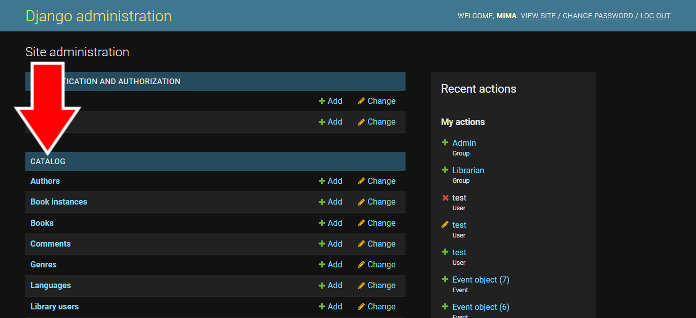Information in the library catalog can be changed from the **Admin Page**. Books, authors, genres, languages, book instances (or copies), and book comments can all be changed from here. Once logged in with an administrative or staff account, select the option you want to edit (for more information on how to log in to the admin page, see section 2.1.1, number 1). Either select the name of the option or press the **Change** button next to it. (Figure 3-13)

Figure 3-13 Site Administration Page Showing Catalog Categories

#### 4. Library Information

Important information about the library can be found on the library website, including contact information, hours of operation, location address, and library events.

##### 4.1 About

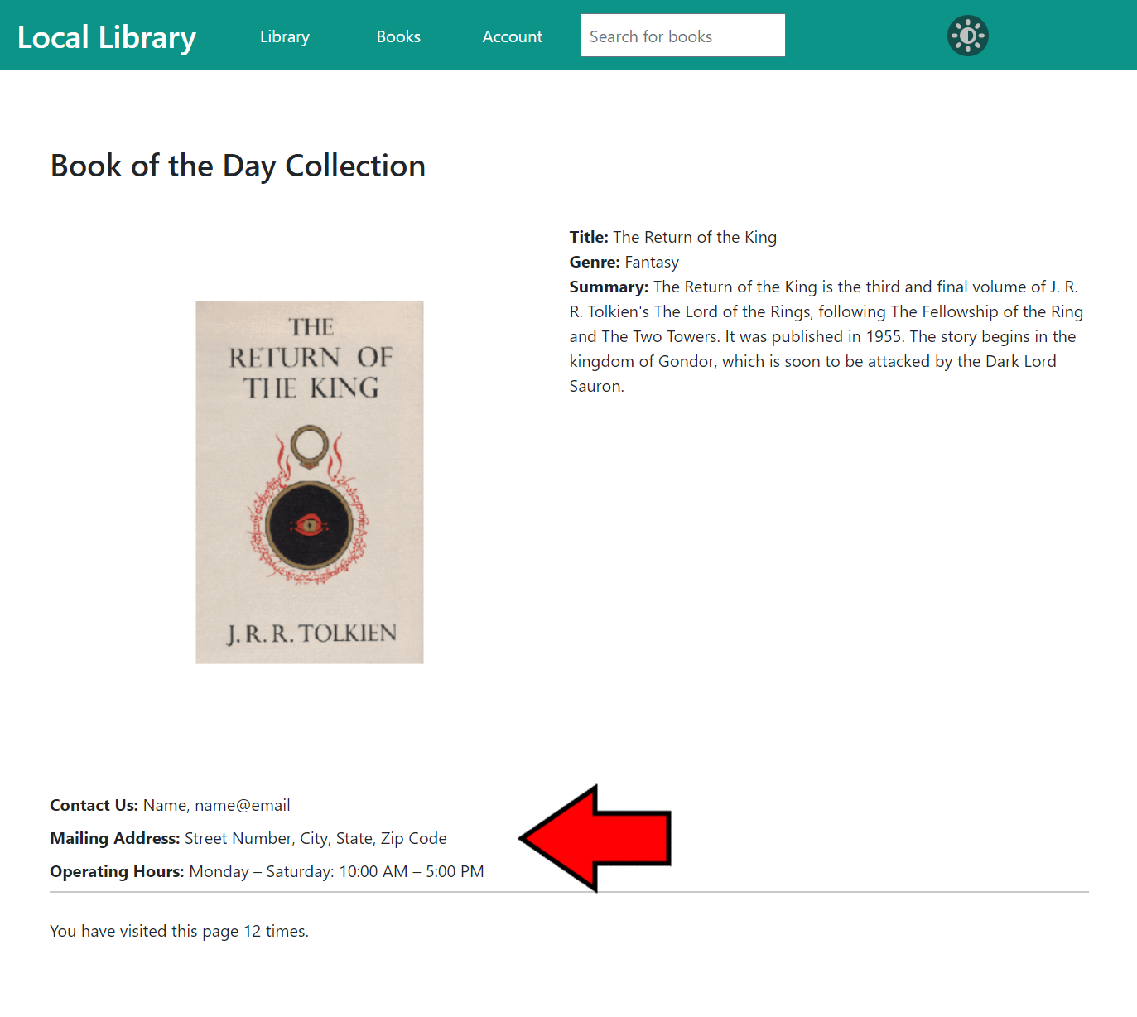Information regarding the physical library can be found on the library website home page, underneath the **Book of the Day Collection**. (Figure 4-1) This section contains the library’s contact information, hours of operation, and physical address.

Figure 4-1   
Library Home Page Showing About Section

##### 4.2 Calendar

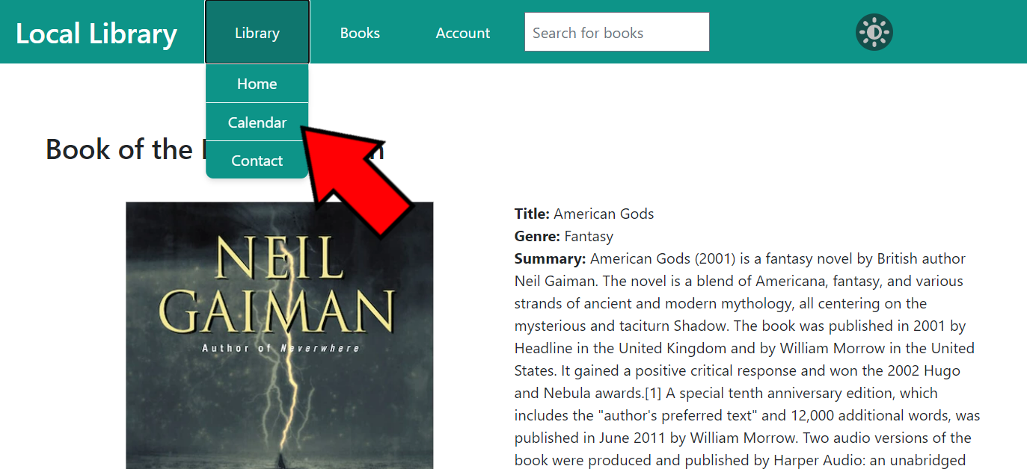The **Calendar** page can be accessed from any page on the library website via the navigation bar at the top. Click on **Library** to open the drop-down menu and click on **Calendar**. (Figure 4-2)

Figure 4-2   
Library Home Page Showing Calendar Button

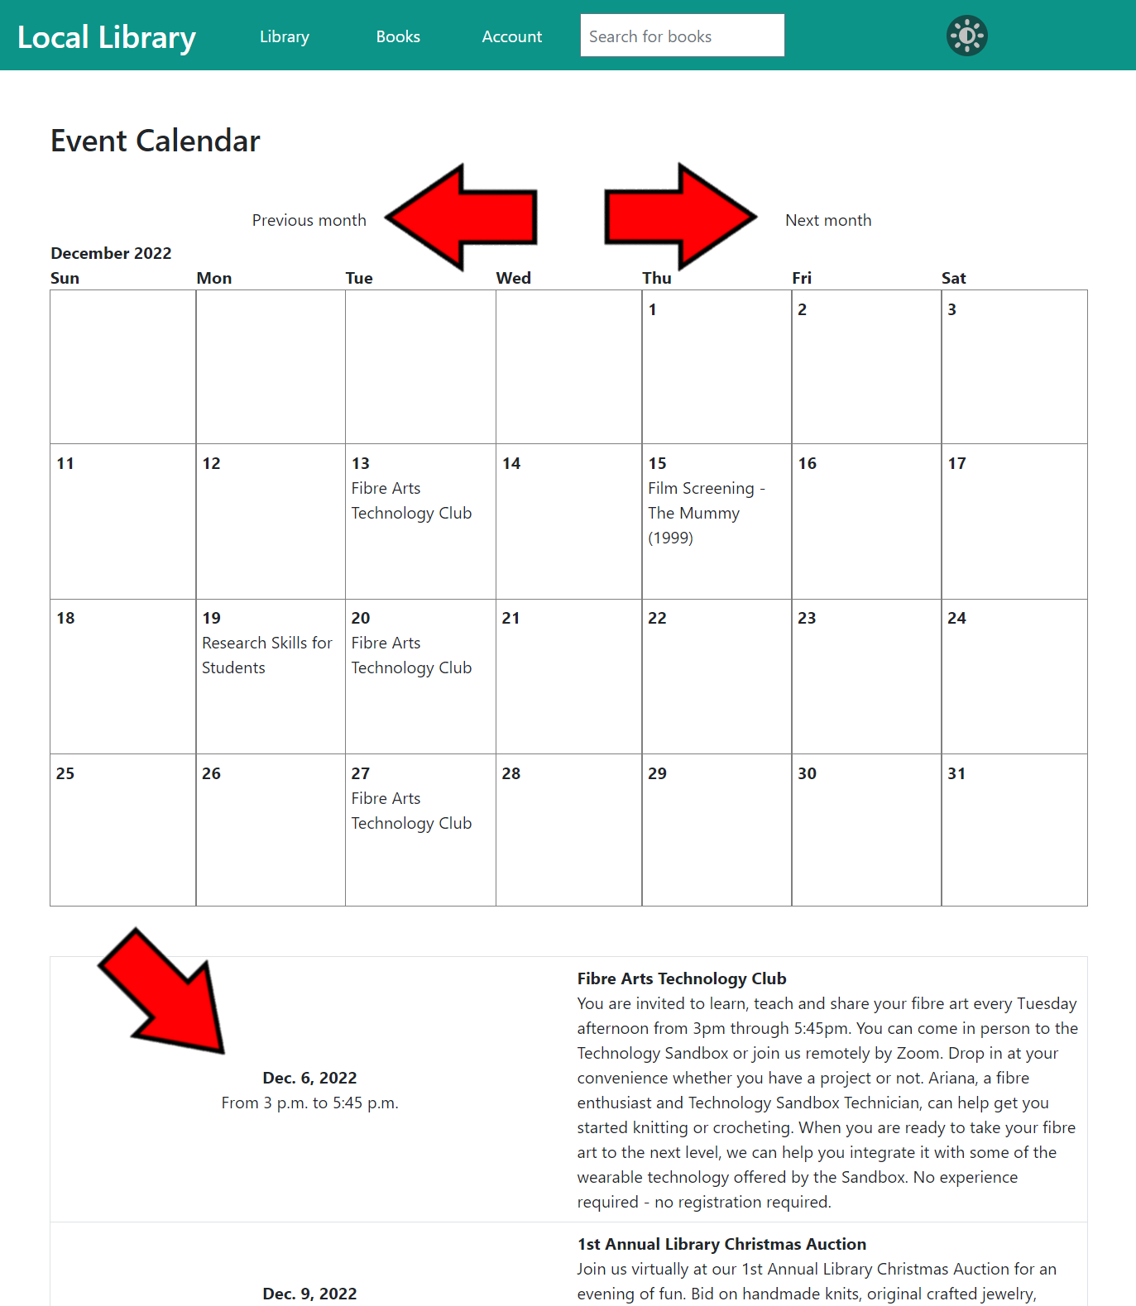On the **Calendar** page is a monthly view of the events the library is hosting. You can change which month you are viewing by clicking the **Previous month** and **Next month** buttons above the calendar. Below the calendar is a list view of the selected month’s events, including information such as event name, day, time, and description. (Figure 4-3)

Figure 4-3  
Calendar Page Showing Month Buttons and Event Details

##### 4.3 Contact

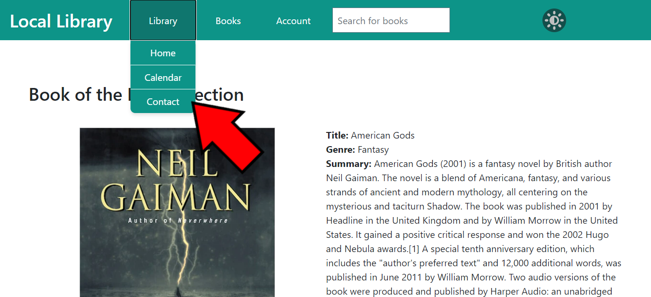The library website has a page where users or visitors can contact the library staff with their questions or concerns. The **Contact** page can be accessed from any page on the library website via the navigation bar at the top. Click on **Library** to open the drop-down menu and click on **Contact**. (Figure 4-4)

Figure 4-4 Library Home Page Showing Contact Button

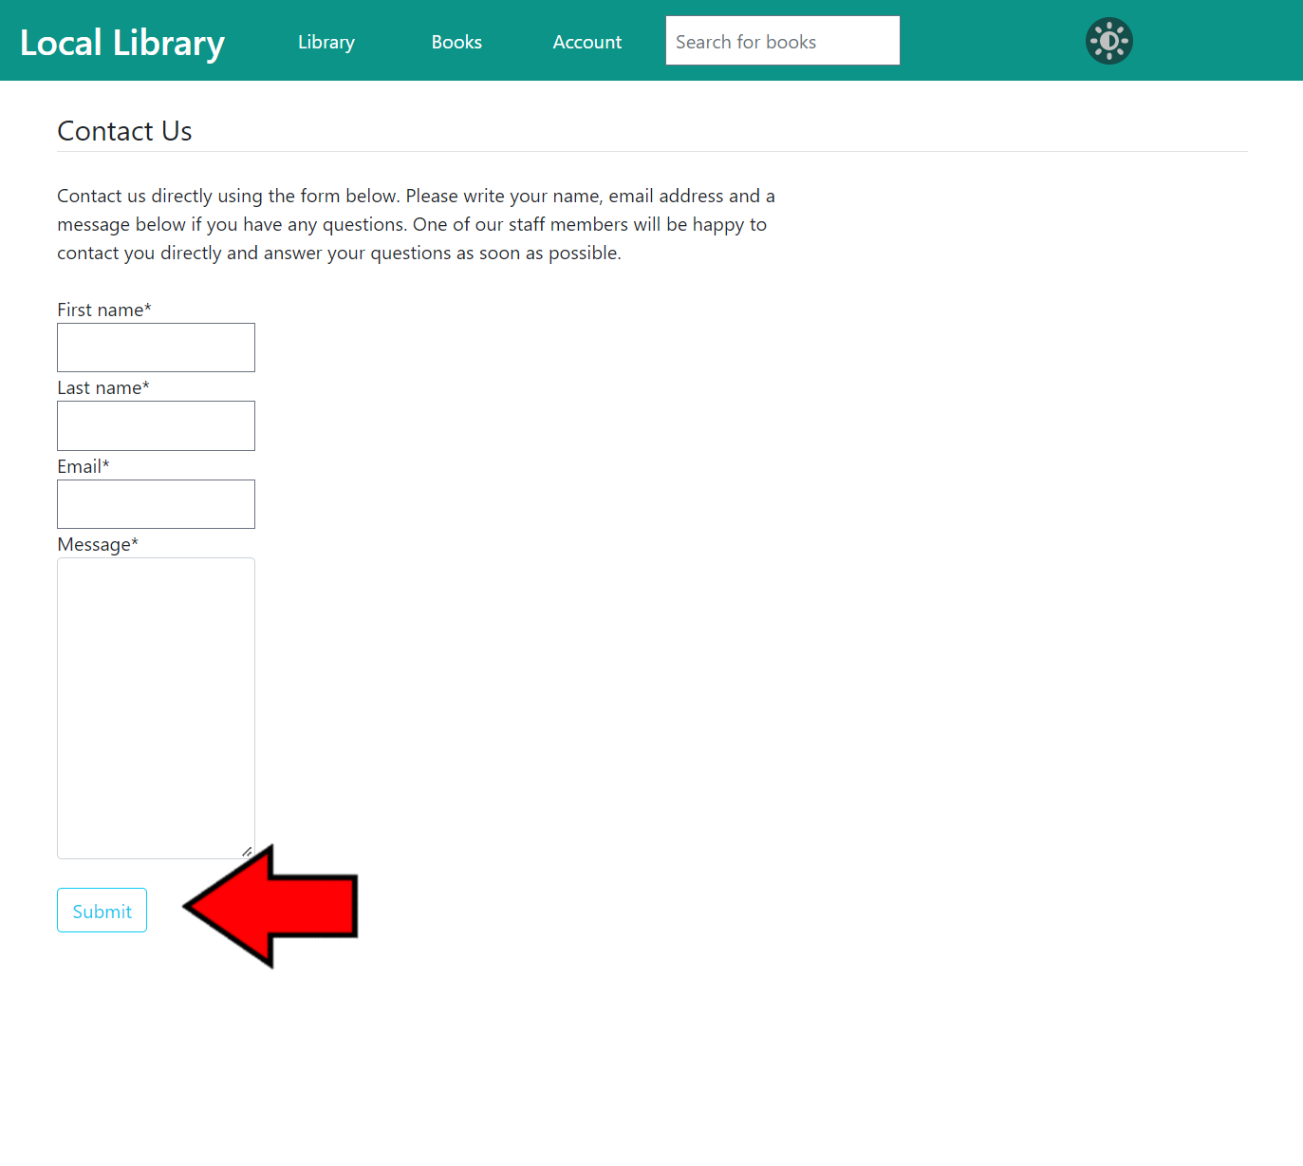To use the **Contact Us** form, fill out each field (**First name, Last name, Email,** and **Message**) then click **Submit** at the bottom of the form. (Figure 4-5)

Figure 4-5   
Contact Us Page Showing Submit Button

###### 4.3.1 Contact Staff View

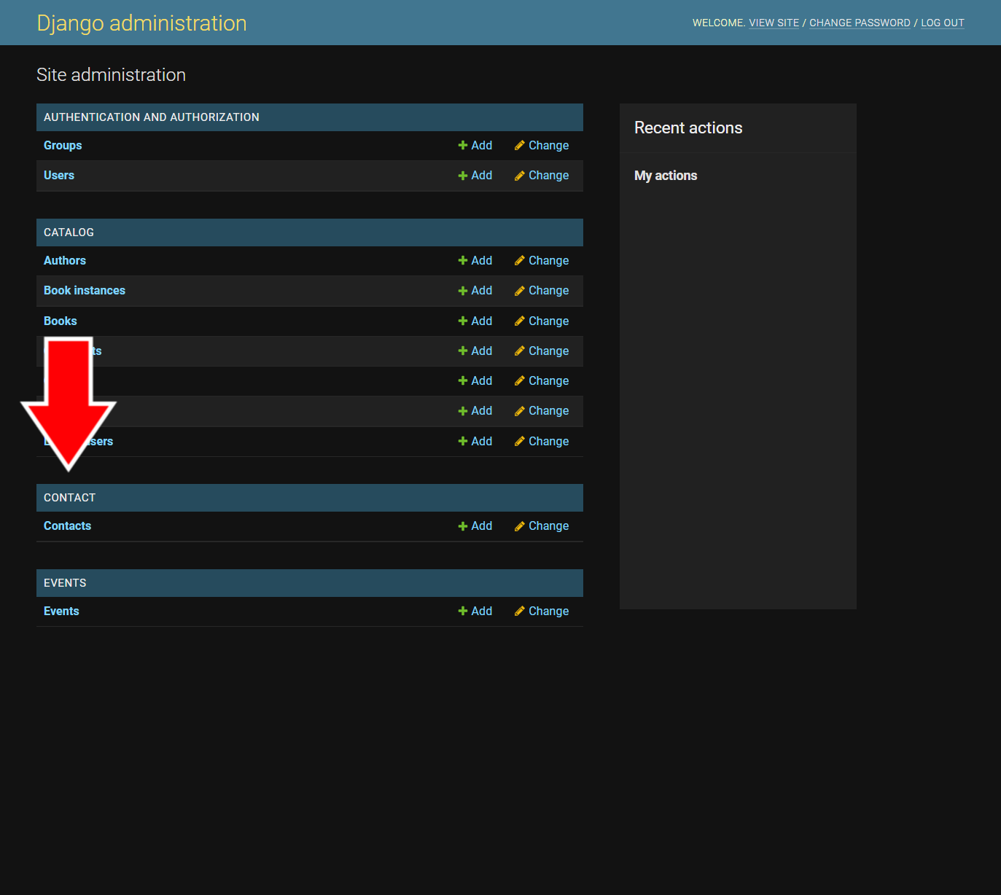Correspondence from the **Contact** page can be viewed on the **Admin Page**. Once logged in with an administrative or staff account, select **Contacts** under the **Contact** category (for more information on how to log in to the admin page, see section 2.1.1, number 1). (Figure 4-6)

Figure 3-13 Site Administration Page Showing Catalog Categories

Figure 4-6   
Site Administration Page Showing Contacts

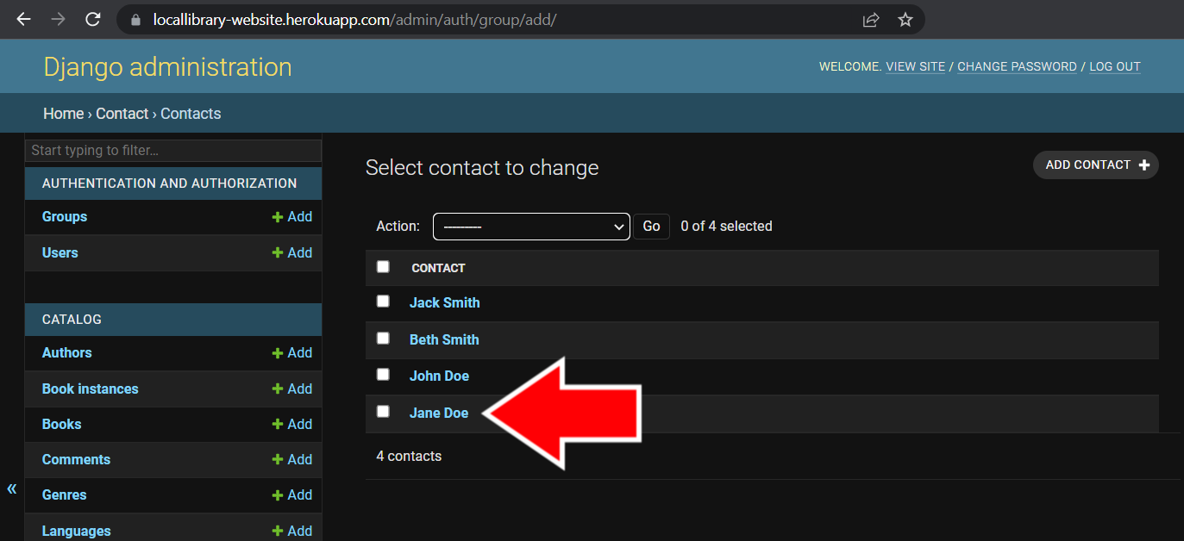To view the details of a correspondence, click on the name of the contact on the **Contacts** page. (Figure 4-7)

Figure 4-7  
Contacts Page

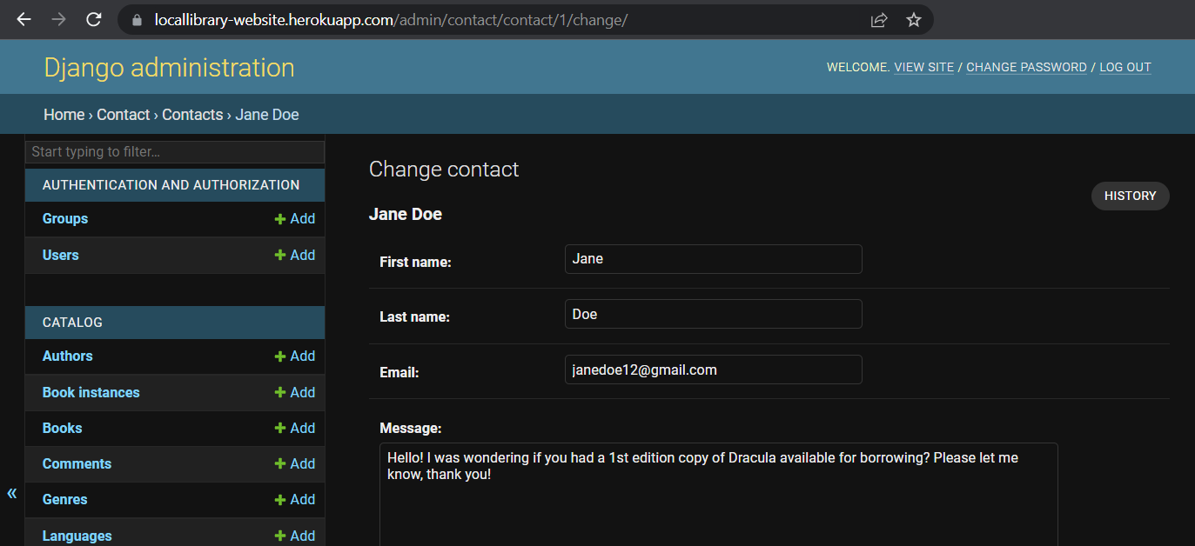On each individual correspondence page is the name of the person who submitted the form, the e-mail address in which to get ahold of them, and a message of their question or concern. (Figure 4-8)

Figure 4-8   
Correspondence Page

#### 5. Dark Mode

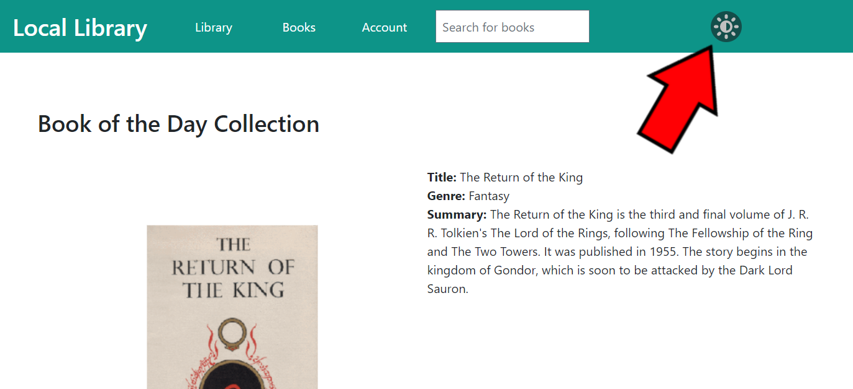The library website has the option to be viewed in **Dark Mode**, which makes the screen less bright to view by changing the colors of the website to dark gray and the text to white. Dark mode can be turned on or off on any page of the website by pressing the **sun button** on the right side of the top navigation bar. (Figure 5-1)

Figure 5-1 Library Home Page Showing Dark Mode Button

Below is a preview of what a page looks like in light mode versus dark mode (Figure 5-2):

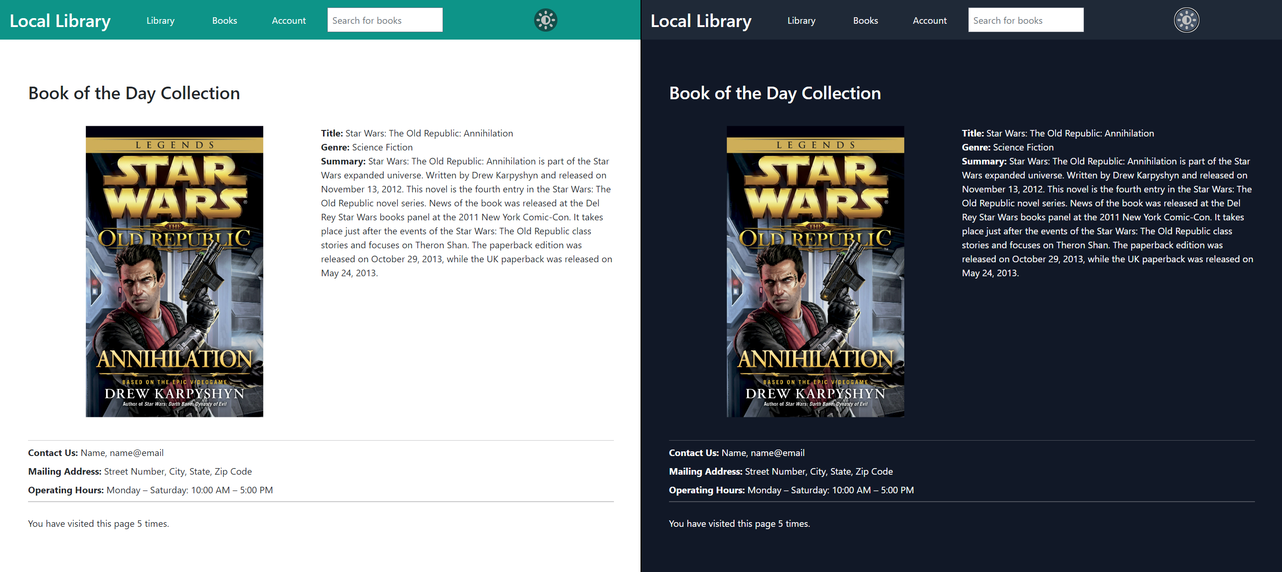

Figure 5-2 Library Home Page Showing Light Mode (left) and Dark Mode (right)

### Installation and Maintenance Guide

#### Getting Started

Before installing the website on your local machine, make sure you have all of the requirements, listed below.

##### Local Requirements

* Python 3

To install the website on your local machine, you need to have Python installed.

For instructions install Python, follow the official guide at the following link: <https://wiki.python.org/moin/BeginnersGuide/Download>

##### Heroku Requirements

As well as the local requirements, running the website hosted with Heroku has all of the requirements listed below. *If you don’t plan on running the website via Heroku, you can skip these requirements.*

* Heroku Account

To host your website on Heroku, you need to first create a Heroku account.

You can sign up with Heroku at the following link: <https://signup.heroku.com/>

Once you have an account on Heroku and have logged in, click the “Create new app” button. Give your app an appropriate name, as it will be the app name for your website, then click “Create app.”

* Heroku CLI and Git

The Heroku CLI allows you to access your website when it is deployed on Heroku. Using the Heroku CLI also requires Git to be installed on your local machine.

For instructions to install the Heroku CLI, follow the official guide at the following link: <https://devcenter.heroku.com/articles/heroku-cli#install-the-heroku-cli>

For instructions to install Git, follow the official guide at the following link: <https://git-scm.com/book/en/v2/Getting-Started-Installing-Git>

* (Optional) GitHub and GitHub Account

Heroku allows you to deploy your website manually or automatically from a repository on GitHub.

For instructions on how to use Heroku with GitHub, follow the official guide at the following link: <https://devcenter.heroku.com/articles/github-integration#manual-deploys>

You can sign up with GitHub at the following link: <https://github.com/signup>

#### Installation

Following is a detailed list of instructions for installing the library website:

1. Install pip

Pip is a package manager to manage your Python code libraries. To install pip, open your command prompt and type one of the following:

|  |
| --- |
| Windows: |
| py -m pip install --upgrade pip |
|  |
| Unix/macOS: |
| python -m pip install --user --upgrade pip |

If you have trouble installing pip, follow the official alternatives guide at the following link: <https://pip.pypa.io/en/stable/installation/>

1. Install virtualenv

To keep all of your packages in an isolated location, you need to set up a virtual environment for Python. One of the most common virtual environments for Python is called virtualenv, although you can use an alternative that works with Python. To install virtualenv, open your command prompt and type one of the following:

|  |
| --- |
| pip install virtualenv |

1. Create a Virtual Environment

Once you have install virtualenv or the virtual environment of your choice, you need to create a new virtual environment. The following instructions will be for using virtualenv. Type the following into your command prompt:

|  |
| --- |
| virtualenv <VIRTUALENV DIR> |
|  |
| <VIRTUALENV DIR> being replaced with the file path to your new virtual environment, which you should put in the website folder. |

1. Installing Website Required Packages

To install the remaining required packages, you need to activate your virtual environment. The virtual environment directory should be located within your website folder. Change the directory of your command prompt to the location of your website folder with the following command:

|  |
| --- |
| cd <WEBSITE DIRECTORY> |
|  |
| <WEBSITE DIRECTORY> being replaced with the file path to the website folder. |

Next, activate your virtual environment with the following command:

|  |
| --- |
| Windows: |
| <VIRTUALENV DIRECTORY>\Scripts\activate |
|  |
| Unix/macOS: |
| source <VIRTUALENV DIRECTORY>/bin/activate |

Once your virtual environment is activated, you can install the website required packages using pip. Type the following command in your terminal:

|  |
| --- |
| pip install -r requirements.txt |

1. Install PostgreSQL 14

To run your website on your local machine with the provided database, you need to install PostgreSQL 14 into your virtual environment. To install PostgreSQL 14, go to the following link: <https://www.postgresql.org/download/>

Select the correct installer for the operating system you are using. Once it is finished downloading, open the executable file and start the setup.

***! IMPORTANT*** – When setting up, PostgreSQL will ask you to set up a password for your databases. Be sure to keep this password in a safe place as you will need it in future steps.

1. Create a Local Database

To run the website locally, you need to create a new PostgreSQL database to hold all of the information in the SQL file in your website folder. Before being able to access the database, you need to create a new one. To do so, type the following command:

|  |
| --- |
| create <DATABASE NAME> |
|  |
| <DATABASE NAME> is replaced with the name you want your database to have. |

When creating a new database, it will ask for a password. This is the password you set when you installed PostgreSQL in the previous step.

Once your new database is set up, you can now import the information for the library website into it. To do so, type the following command:

|  |  |
| --- | --- |
| psql -U postgres -h localhost -d <DATABASE NAME> -f db.sql | |
|  | |
| -U postgres signifies your username. Unless you changed it, the default is “postgres.” | |
|  | |
| -h localhost is the location on which you are hosting your database. Unless you changed it, the default is “localhost.” | |
|  | |
| <DATABASE NAME> is the name of the database you created in the previous step. | |
|  | |
| -f db.sql is the file that contains all of the database information for the library website. | |

After running this command, it will prompt for a password. This is the same password you set up when you installed PostgreSQL.

1. Updating Website Settings with Database Information

Before you can deploy your website locally, you need to update the database information in the library website settings.

Open the folder containing the website files. Find the folder called “locallibrary” and open the settings.py in a text editor. Find the section called #Database, which should look like the following:

|  |
| --- |
| DATABASES = {  ‘default’: {  ‘ENGINE’: ‘django.db.backends.postgresql_psycopg2’,  ‘NAME’: ‘<database name>’,  ‘USER’: ‘<username>’,  ‘PASSWORD’: ‘<password>’,  ‘HOST’: ‘127.0.0.1’,  ‘PORT’: ‘5432’,  }  } |

You need to update parts of this section to work with the database you set up in the previous steps:

<database name> should be the name of the database you created in the previous steps.

<username> should be the username you set up when you installed PostgreSQL. If you did not change the username, the default is “postgres.”

<password> should be the password you chose when you first installed PostgreSQL.

Once these steps are successfully completed, you should be able to run your website on your local machine. To see how to run your server on your local machine, see the *Local Deployment* section under *DEPLOYMENT*.

#### Deployment

##### Local Deployment

Once you have finished installing and setting up your website in the previous sections, you can now deploy your website on your local machine. Following is a detailed list of instructions for deploying the library website locally:

1. Run Server

To run your server locally, open a command prompt. Change the directory to the website folder and activate your virtual environment (for more information on running your virtual environment, see *INSTALLATION* step 4).

Now, you can start running your server. To start the server, type the following command:

|  |
| --- |
| python manage.py runserver |

This command starts the server running on your local machine.

1. View Your Running Website

Once you have started your server, you can view it on your local machine. Open a web browser and type the following into the URL space:

|  |
| --- |
| 127.0.0.1:8000 |

This will pull up the website in your browser, which is now running locally. You can interact with the website as you would if it were hosted on the internet.

#### Heroku Deployment

All of the website files have already been adjusted to work with Heroku. You can deploy with Heroku either with Git or GitHub. Following is a detailed list of instructions for deploying the library website on Heroku:

1. Make a Git Repository

To make the website directory into a repository, you need to use Git to initialize it. Open a command prompt, change the directory to website folder, and type the following command (for more information on running your virtual environment, see *INSTALLATION* step 4):

|  |
| --- |
| git init |

This creates a repository that we can use with Heroku.

1. Make a Git Ignore File

In order not to commit your virtual environment to Heroku, you can make a git ignore file in your repository. To do so, create a text file named “.gitignore”.

After creating the file, open it in a text editor and add the following:

|  |
| --- |
| <VIRTUALENV DIRECTORY>/ |
|  |
| <VIRTUALENV DIRECTORY> being replaced with then name you gave to your virtual environment folder. |

1. Add Your Files to Git

To be able to push your repository to Heroku, you first need to commit your files to the local repository you created in step a. To do so, type the following commands:

|  |
| --- |
| git add . |
|  |
| git commit -m “Initial commit” |

These commands add and then commit your files to your local repository. Now, you’re ready to work with Heroku.

Once you’ve added your website files to a Git repository, you can either deploy on Heroku via Git or GitHub. Following is a detailed list of instructions for deploying the library website via Git and GitHub:

1. Git
   1. Login to Heroku CLI

Before you can push your repository to Heroku, you have to login to the Heroku CLI. To do so, type the following command:

|  |
| --- |
| heroku login |

The CLI will ask you to press a button to login and will open a browser for you to enter your credentials. Once logged in to Heroku, you can proceed.

* 1. Push to Heroku

Finally, you can push your website repository to Heroku and update your Heroku database. Make sure the db.sql database file is located in the root folder of your website directory. To do so, use the following commands:

|  |
| --- |
| heroku git:remote -a <APP NAME> |
|  |
| git push heroku master |
|  |
| heroku pg:psql -a <APP NAME> < db.sql |
|  |
| <APP NAME> being replaced by the name you gave to your app on Heroku. |

Once you’ve pushed your files to Heroku and updated the database, you can press the “Open app” button on the Heroku website of your app and view the website live.

1. GitHub
   1. Create a GitHub Repository

Logged in to your GitHub account, create a new repository. Give it a meaningful name as it will be the repository for your website. Click “Create Repo” at the bottom.

You can add your files to this repo either through the use of Git or by manually uploading them.

* + 1. Git

Make sure your command prompt is in your website folder. Use the following commands to add your files to GitHub:

|  |
| --- |
| git remote add origin <REPO URL>.git |
|  |
| git branch -M master |
|  |
| git push -u origin master |
|  |
| <REPO URL>.git replaced by the URL for your repository.  Ex: https://www.github.com/YourUsername/RepoName.git |

* + 1. Manual Upload

On your repository’s GitHub page, there is a link called “uploading an existing file” under the “Quick setup” section. Select the link and you can either drag your files into the browser to upload them or click the “choose your files” button and you can select the folder from your computer.

* 1. Connect GitHub to Heroku

On the Heroku website, logged into your account, and on the app you created for your website, click the “Deploy” button at the top. Further down the Deploy page, you’ll find a section called “Deployment method.” Here, you can add your GitHub account to Heroku, which will require you to give Heroku permission to access your GitHub repository.

* 1. Deploy

Once your Heroku app has been linked to your GitHub repo, you can deploy your website on Heroku. On the same page that you connected GitHub to your Heroku app, there are two sections called “Automatic deploys” and “Manual deploy.”

* + If you want your website to be automatically updated every time you change files in your GitHub repository, you can select the master branch under “Choose a branch to deploy” and then click the “Enable Automatic Deploys” button.
  + If you want to manually deploy your files from GitHub whenever they are changed, you can do so under “Manual deploy.” Select the master branch under “Choose a branch to deploy” and click the “Deploy Branch” button.

Once you have done either of these options, under the “Activity” tab of your Heroku app, you can see the progress of your deployment. To see the newly deployed website, press the “Open app” button at the top of the screen.

#### Maintenance

##### Website Publishing

Keeping your website running and updated is an important part of website maintenance. The responsibilities of maintaining a published website are covered by several different categories.

* Editing/Adding Content

It is important to keep everything on the website up-to-date and accurate. Any time there is a change to the catalog, library contact information, or library hours, the website must be edited to display the most recent information.

* Design

The most significant aspect of a website is its visual and interactive presentation.

This doesn’t only apply to aesthetics, but also to accessibility. As new rules and regulations come out about the accessibility of websites, the website needs to be kept updated with these new requirements.

* Developing

Building the content and design into HTML files is the responsibility of a developer. Adding new features, changing current features, creating more interactivity, etc. all fall under this category.

##### Quality Assurance

Quality assurance is the process of keeping the website free of errors, mistakes, or bugs.

The process of collecting data for quality assurance purposes consists of examining the website for any issues. This includes checking for the following:

* + Broken links
  + Missing content and images
  + Spelling and grammar
  + Browser compatibility
  + Application functionality
    - Account login
    - Account signup
    - Contact form
    - Book comments
    - Book renewals
  + Accessibility conformation
  + Standard design

Issues found while collecting quality assurance data should be sent to the developer for correction or update.

##### Contact Monitoring

Managing correspondence received from the Contact page of website is a vital part of website upkeep. It is important to acknowledge and respond to client messages in a timely manner.

Contact can also come in the form of comments on any of the books in the library catalog. Thus, going through the comments and checking the messages’ relevance and appropriateness.

However, responding to messages is not just about answering questions about the library. There may be some issues that arise from the website that are not in quality assurance testing. The following steps were put in place to help you manage the website’s contact messages:

1. Collect the information
2. Acknowledge receipt
3. Investigate
4. Respond and follow-up

##### Infrastructure Performance Monitoring

While the library website was designed to either be hosted on a local machine or via Heroku, it is still important to keep the systems running the website up-to-date and free of oversights. This includes monitoring the health of the following systems:

* Server response times
* End-User response times
* Server error rates and types
* Traffic patterns
* Timeouts

If the website is deployed via Heroku, most of the above are managed by Heroku. However, it is still important to keep on top of these issues and have them resolved with Heroku’s staff should some issues arise.

#### Development

Most of the development of the website is as simple as changing the text in files or managing catalog content via the library admin website. However, there are a few instances of updating the library that require a different approach.

##### Models

The models (located in models.py in several of the subfolders of the website directory) are a collection of definitions for storing data. For example, the author model has defined information variables such as name, date of birth, etc. The models tell the database what information is stored in each table. In the previous example, author would be a table with rows for name, date of birth, etc.

Should you want to change the models to add more information, change how information is managed, or completely adding a new model, there is a specific process you need to go through to update your database to reflect these changes. Following is a detailed list of instructions for update the models and the database:

1. After making the changes to the models.py file, you need to make the “migrations” to the database. Open your command prompt and change the directory to your website folder then activate your virtual environment (see Installation, step 4 for how to change directory and activate your virtual environment).
2. There are two steps to making the migrations to the database file on your local machine (db.sql). The first is called makemigrations, which packages up all of your individual changes into a file that can be easily read by your database. The second is called migrate, which does the actual job of adding your changes to your database. To activate these commands, type the following in the command prompt:

|  |
| --- |
| python manage.py makemigrations |
|  |
| python manage.py migrate |

Once these changes are finished being made, you can run your server and see how the changes have taken effect.

1. (Optional/Heroku) If using Heroku, you need to apply these changes to your Heroku database as well. This can be done via the Heroku CLI. After following the previous two steps to make the migrations on your local machine, you then make the changes on your Heroku app. Log in to the Heroku CLI, push your code to Heroku (see Heroku Deployment for information), then type the following command:

|  |
| --- |
| heroku run -a <YOUR APP NAME> python manage.py migrate |
|  |
| <YOUR APP NAME> being replace with the name you gave your app on Heroku. |

This will migrate the changes on your Heroku database.

##### CSS

The library website uses a framework to help efficiently write the CSS (cascading style sheet) of the website called Tailwind. This makes it easier to change how each page is displayed and designed. In order for your changes to take effect, you need to have Tailwind running. Every time you save a change to an HTML file, Tailwind automatically takes your changes and adds them to the stylesheet of the website.

To start using Tailwind while editing your website, use the following steps:

1. Open your command prompt and change the directory to your website folder then activate your virtual environment (see Installation, step 4 for how to change directory and activate your virtual environment).
2. Start the Tailwind service by typing the following into your command prompt:

|  |
| --- |
| python manage.py tailwind start |

This activates the Tailwind service and you can now start changing the styles of your HTML files. Tailwind uses specific keywords kept in the class of each page element to determine what changes need to be made. See the official Tailwind documentation for more information: <https://tailwindcss.com/docs/>

Every time you save your HTML file, Tailwind updates, so be sure to save often for the changes to take effect.

1. Once finished editing the HTML pages, press Ctrl + C in your command prompt to stop the Tailwind service.

### Shortcomings/Wishlist

* The Library Website should have a children’s section.
* There should be a webpage for children’s selection of books. It should list all the books that are tagged for children. There should be a variable used to tag children’s books.
* The books should have different format options.
* Pagination should be replaced with a "load more" button.
  + When viewing a list, users should be able to press a “load more” button at the bottom of the list. This way, they can scroll back up to find a book they’ve already seen.
* The librarians should have the option to disable a user account’s borrow feature.
  + This would protect the library from users who damage or fail to return books.
* The CSS needs to have tailored options for users with smaller screens.
  + Websites show up differently on smaller screens (e.g., phones and tablets) and need to have their CSS styles verified for compatibility. Some CSS rules might need to be put in place to make sure the website works properly.
* Users should be able to view, add, and remove books from their own personal reading list.
* The CSS for the website needs a central theme.
  + With Tailwind, there can be a set of design rules for the website and its elements.

# References

Arpitgoyalgg, et al. “Django Web Framework (Python).” *Learn Web Development | MDN*, 8 Oct. 2021, developer.mozilla.org/en-US/docs/Learn/Server-side/Django.

Diffily, Shane. “The Website Manager's Handbook.” *Website Maintenance*, www.diffily.com/book/website_maintenance.pdf.

RAVINDRAN, ARUN. *Django Design Patterns and Best Practices*. 2nd ed., PACKT Publishing Limited, 2018.

“Django Documentation.” *Django Project*, docs.djangoproject.com/en/4.1/.

“The Python Tutorial.” *Python Documentation*, docs.python.org/3/tutorial/index.html.

“Use Case Diagram Tutorial.” *Visual Paradigm Online*, Visual Paradigm, online.visual-paradigm.com/diagrams/tutorials/use-case-diagram-tutorial/.